**Akshay Sainis React**

**Day 3:**

Parcel is a bundler

This below all are transitive dependiecies for such below operatrions parcel is depended on some other packages

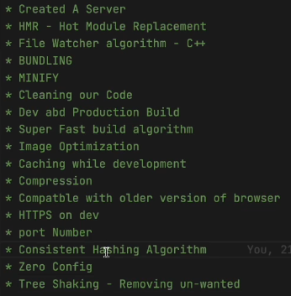

React cant make performance app alone,it requires diff thngs like parcel,

* Dev dependencies and nrml depeendienecies

What we have learned:  
**-> npm init it gave package.json**

* For installing parcel,
* Npm I –D (for dev dependencies) parcel
* Cmd to executr our project: npx parcel index.html
* It created parcel.cache and a server for us, it enables many things like in the above img
* Installing react: npm i react
* Then, import, for that, we have to give type=”module” in script tag in html file,
* Diff b/w packagelock and pck.json
* Should I push parcel cahce on gitignor ? YES
* You should everyting in gitigonre that u can regenerate on server

**HomeWork:**

Should have the curiosity

**DAY 4: React-Laying the foundation**

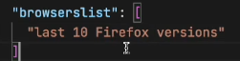**broweserlist:** it means it definetly work on this, but other browser also it does, but few features may not be supported

**Polyfil:** a code which is replication for a newer version of code

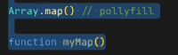we do not do this, babel does for us(new version to older version).

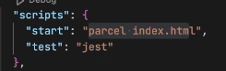**For building our app**, we type the cmd **npx parcel index.html** Rather we can add these cmds in script and jst have **npm run start**

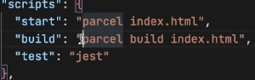Today we are going to talk **about jsx, babel**, **Npm init configuration for managing dependiencies,** Babil is a node pckg, a lib.

Same can be happened with build also, we can write build script, now we can type **npm run build**

**Npm start and npm run start are same**

* In dist folder, we can see, no **conslole logs been removed, this can be done using pckg called**, **babel plugin transform** remove console, for this we are using a plugin we are configuring it
* **npm i babel-plugin-transform-remove-console --save-dev**
* 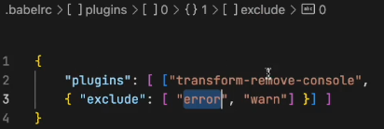now after installing it wont work we need to configure it, will be creating .babelrc file, writing this in file
* 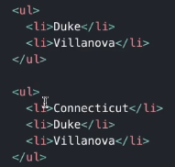Then npm run build which will create files in dist fldr, it will not contains console.log but it contains .error
* 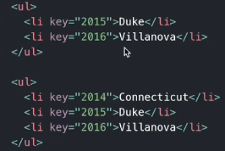 **Check react reconsilation key, Read about** Diffing algo, i.e., we uses key, consider the li tag, if we want to add one more li tag on top of prev Ii tags **then it is time consuming, as need to rerender the whole dom**, which **effects changes in dom tree,** **Therefore** it makes easy to **use key in such scenario**
* **How does creatElement woks? .**
* Well it is creating an object, React.CreateElement is creating an object, which then conv into html code, then put upon the DOM.
* **Creating huge html structures with createElement will mess things up, instead of this we use jsx**
* 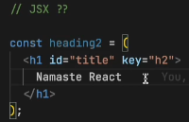**Is jsx html inside** JavaScript ? T/F -> it false
* It is a html like syntax but not html
* Diff b/w html and jsx
* In jsx we use camelCasing i.e, tabIndex, not tab-index **and className not class**
* How does jsx executes the code, if u type in browser it doesn’t supports it, **babel understands it**,
* Img tag in jsx ?
* Babel comes along with parcel , html in () Is known as jsx expression
* Now let’s learn **React** **Components**
* Everything is a component in react, **we got 2 types of component, functional(NEW) and class(OLD)** in this course will woking with functional components
* 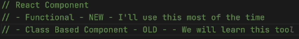
* **Functional Component**  is nothing but a function, A function returing a react ele is known as react functional comp
* For any Compoent **the name starts from a Capital letter**, for good practices
* 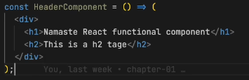No need of () for single line code, for multiple lines need () can also be written as this, without any return or arrow function thing.
* It is returning jsx
* When we have to render the functional component then will render this way **<function1/>,** and react ele, nrmlly
* We can also use react element inside function using **{heading}**
* Any peace of js code can be written in {}
* Now lets say the api, is returning some malicious code, such attacks are known as cross site scripting attack (xss), by injecting some js code, if it is able to run in our lap then it takes data, **BUT JSX takes care of such attack, i.e, it sanitizes the code and protects from such attack**
* **Component Composition:** such that, we’ve to use a component inside a component

**Revision:**

* Browserlist
* Babel, and its config
* Why do we need keys and diff algo
* What is jsx? It is using React.CreateElement behind the scenes
* Functional component, and class its using, {} </>

**Day 5: Talk is cheap, show me the code**

* We can be able to write javascript code inside these {}
* We can call our functional component like {Title()} or <Title/> or <Title> </Title>
* React is a proper library
* Is jsx / es6 is mandatory for react-> NO
* **Now Let build our APP**
* Will be building **Food Villa App**
* Before writing the code, do plan about our App
* 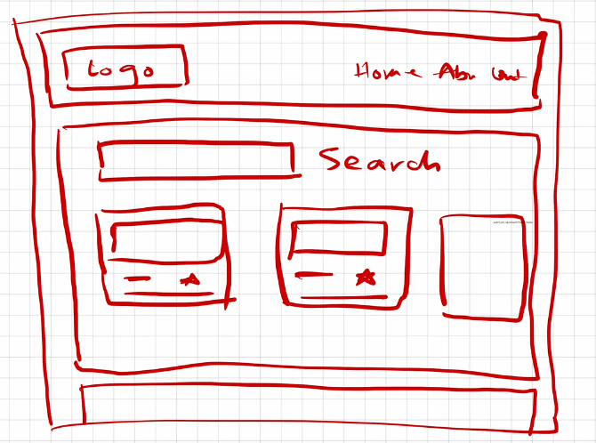
* 1st let’s build header
* 1st will be building our layout->structure for that build a component name APPLayout
* 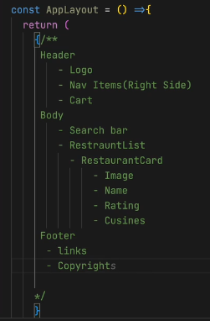
* Start coding for header component, **add home, about, contact**, cart put **some CSS to align it**
* 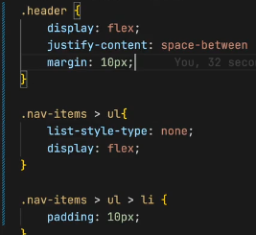
* Add an image/ logo in title component Give a class and resize it also try to add anchor tag
* **NOTE: Any piece of jsx component, there can only be 1 parent**
* i.e., const jsx = <h1>hii</h1> is Correct but
* const jsx = <h1> hii </h1> <h1> hello </h1> is Wrong
* Therefore, we can wrap this thing inside div
* <div></div>
* Therefore, we can use React.Fragment

**Now will be building our resturent card**

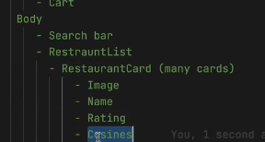

**We’ve** to work on our body part

Whenever I’m having this restaurant cards then I need to pull data from some where, So remember this thing, Whenever I’m using UI I’will all way’s be conserned about where will my data come from ?

* 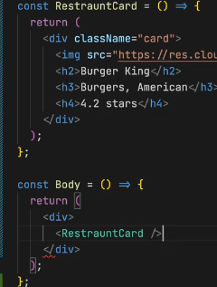For now we will be using hard coded data, then will also learn how to use it through API’s as well
* Will be constructing a functional component with name restaurant card, which will be **returning a jsx element**
* After creating the card, put this in Body, make the returning stmt as div and add **the <Restraurcard/>**
* **Now, give some styling in css to card**
* **It will appear on browser.**
* Now, as we’ve hard coded our restaurant card, but the img, name, lable, rating and all is diff for all, Therefore, we need to make it dynamic
* 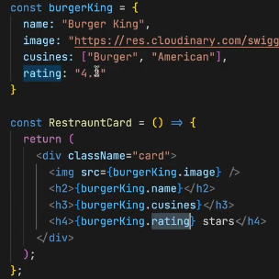For that, let’s utilize the javascript, will be creating a js obj, to do dynamic access of data we can do this way.
* To have a (,) in cusines as it a array, we can use join, i.e., **burkerking.cusines.join(“,”)** this how you join items in an array.
* Now, we made our data dynamic, but in the real world there will be so many restaurant, if function call them again and again not good,
* **Display flex, is useful to view the div comp, in horizontal format, also flex-wrap : wrap, can also use grid do ur css**
* **Now lets try to make our all cards dynamic**,
  + In real world the data comes in list formate, such that there will be so many of it.
  + 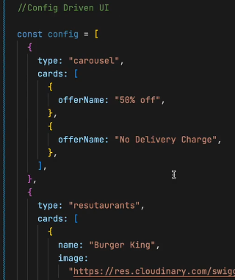**Config driven UI:** dynamic ui is called as config driven UI, such that, the whole ui is driven by a config which is sent by a backend.
  + **It is Very much useful if you built your Project, using config driven UI**
  + How, will be able to control our UI with backend.
  + As shown in img, if at some place there are no offers and there is no need of any carousel, then backend wont send us such kind of cards, will be directly showing the resutaruants.
  + **In your system desingn round you have to tell this to your, interviewer.**
  + **Now,** Will be building such kind of dynamic UI
  + **Let’s use real data, of swiggy not** the mog data
  + For this, go to inspect, then FetchXR then click on preview it shows the data, or also try reloading the data. Now copy the restaurants data into your code, now how to use that data? Use it normally as shown in img.
  + 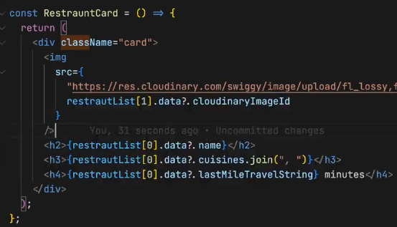After getting the data from swiggy, now how to use it, will be using as restuarentList[0].data.name suppose if the name doesnot exist then u’ve to use this **restuarentList[0].data?.name this called optional chaining** (JS thing), also the image can be used as shown
  + Now let’s try **to make this dynamic**, such **that the 1st, 2nd** **and 3rd card should** be showing the info as of list ordering
  + 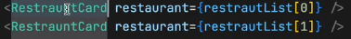**1 way is to use props**
  + **Props->properties,** i.e, I’m passing my data into my component, functional comp is just a function like in js
  + In functions we’ve concept of arguments and parameter, we pass in arguments we receive parameters
  + In react to use, it as we are passing the props, to use in function we’ve take in as parameter, and can name it anything (props).
  + **Props is like jst a nrml function call as we do in our codes**
  + 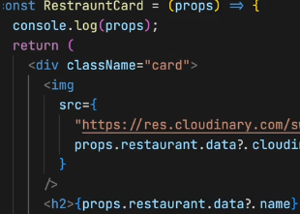We can pass any no of args
  + It is received as a para here
  + Now, here’s the thing come up by cool developers, what they do is **destructuring** the object, instead of props use,
  + Now we don’t need props. I can use my restaurant
  + Again you can destructure it like this, with this we can directly use the tags.
  + 
  + For this will call like: 
  + **If lets say you have destructured the whol at params u got name, cusines, ratings and all so can you pass from u args this way ? well the answer is NO.**
  + **What u do is, u cann pass each with separate tags from the args, or u can use (…) this operator to jst travers all**
  + 
  + It will work, It is your **spread operator, this is JS es6, in {} can write any** js
  + So**, what if there are 50 cards, then** we cant go on writing this way, therefore, we **uses for loop, but** in the industry we don’t use for loops instead e use **MAPS,** but also we can have for loop,
  + 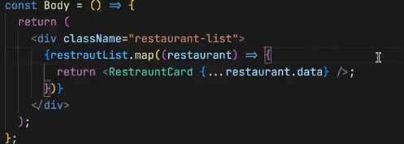**For maps, as the restaurentList is an array, restaurentList.map(give a callback fun), the fun takes each obj, and for each obj I want my fun to return jsx, which is my <restuarentCard/>**
  + **Everything we’ve builded is like a config driven UI**
  + **Today, we’ve made many things, we made up our header, nav bar, logo, cards (coming from swiggy),**
  + **Now lets dive into virtual DOM**
  + Virtual dom is not jst the concept of react it is a software engineering concept.
  + **We keep a representation of the dom, with us this is known as virtual DOM,**
  + **Why do we need it ?**
  + **A: we need it for reconsilation, reconsilation is an algorithm that react uses, to diff one tree from other and it determines what need to be changed and what not in the ui.**
  + Here the key concept comes into the picture, i.e., lets say we got multiple divs and one dive is been added, as we know the virtual dom only changes the updated div, Therefore to identify the divs we use **keys.**
  + **VirutalDOM is the representation of the dom, and react uses something known as reconsilation, it will find out the different between the tress and only the portion that is required,**
  + Hotmodule reconsilation, this is different, this is on file, which is been down by parcel.
  + ****Also read about **React Fibre**, which came in react16 its new reconsilation engine and it is responsible for div
  + **Now, you should never forget to give key**
  + **Why don’t we use index as the key ? **
  + It will not give error, but u should never have to use index as your key.

**Now lets revise:**

* **1st we**  did planning, then learn about <> </> this
* **Then** we also learn about functional component
* Then we started building our card.
* Then we builded our UI
* Then we had our hard coded data
* Then we made our card dynamic, Then we wanted multiple cards to be dynamic
* Then went to swiggy api, then also learn about carousal of swiggy, i.e., wants to hide and all, such thing are known as **config driven UI, such that u give me a config, my ui will render automatically**
* **Then** we started using props.
* **Such that, pass**ing args
* **Then we** studied about map function and also spread operator
* **Then**  we learned about Virtual dom, reaconsilation algo
* **Then** we learned can I have index as a key

**Practice session:  
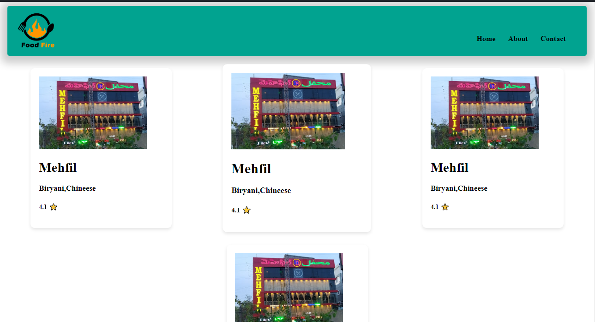**

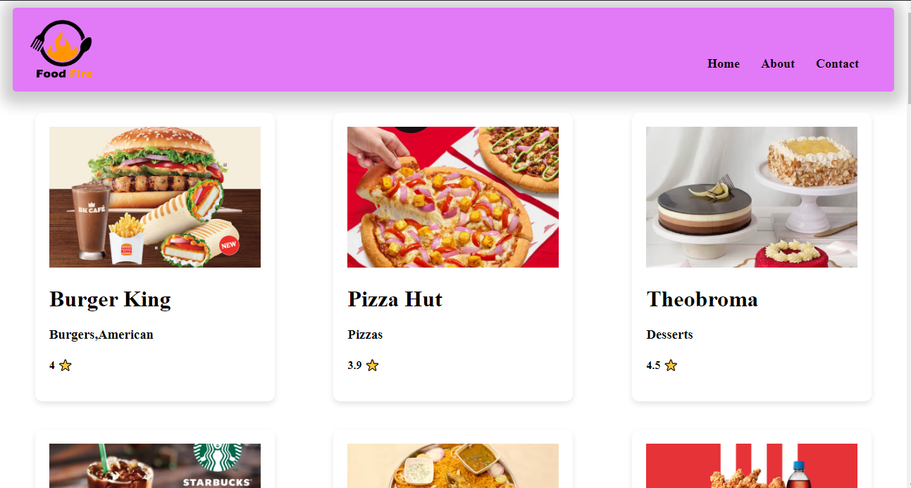

**Day 6: Let’s get hooked! 01-02-2024**

Created a folder named src, do we need to create folder well not, but maintaining proper folder structures this gives us a better modular structure and findable, src is a comman convention been using used in the industry, Now will keep all our files related to our app inside src folder.

* React folder structure, read about it. We can distribute our files depending on the feature of the app .
* Create a src folder then a comp folder, then a file name Title.js add the title code in it, then export the Title component from the file, then import it in app.js and use it
* There are 2 ways of exporting it 1. Export default Title, it will export Title as default i.e., Learn about it, also when u export by using default u use it like
* 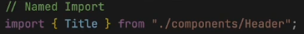Now have header and title components in same file, now can I export both of them using default, U can’t I can export only one thing, so if I export this way such that**, exporting by name** then u’ve to use like

In default import u don’t put {} for named import u have to u {}, when to u use what??

* If you named exported both the comp then you can import this way
* Now if my Header is default export then we can import this way  , does this name have to match the export one, well NO for the default export there is no need, you can change the name, but also try to keep the same name it is good practice.
* And I can also import as ./components/Header.js it will also works fine. And in the react dev community some people are try to name there file as .jsx cause it contains react code in it. And you can also import as .jsx
* Sometimes this can break when you use external library.
* **Now if I’m exporting all components** and named comp, then I can import like this  and I can use like , Now you must be getting why we used  in the code.
* **Now,** What should I be following, Well I try to **export default Header,** Cause I do not export what is not needed, cause title in not needed in App.js right we need it only in our Header component, so I don’t export it, So I jst import things without {}, I only use it when there is real need.
* **HomeWork:** named import, diff ways to export, export default, how do u export a default exp, a named export, what happens when u write *, also what happens when u name ur files.
* **Now** let’s try to create components for other files as well,
* Let’s create for body comp, create a body.js also do it for footer, so u can destructure you files as much as u can
* **Now Listen very important thing** **we also’ve to create a config** file in our project i.e., **config.js, Well** I put all the **hard codded things into my config file, n**ow I’m using a url for image, suppose I want it in other file as well, so I need to again copy paste it there, SO I just wan to import this from one place kind a global var, **in some company it named as constant.js** files as well.
* Here’s how you can’ve your url, better to export as named also try to have the restrauent list in the constant.js file and export it, and import it in body file. Now also create a new file for the RestaurantCard comp as well and use it in body file and we need that img url in Card comp file.
* Now our code looks cleaner.
* So, you’ve to always keep your code cleaner and maintainable this was 1st part of this session.
* Where to keep our css file, generally will be using tailwind css later onn, for that u don’t need css file, for now keep the css in one file only not in sub folder.

**Now will be building the Search bar functionality**

* Now, where do I need search I need it in my body, jst above my res List , give a className “search-container”
* 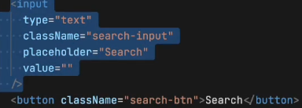Search container should I’ve input tag in it, also the input should have the value, let it be empty for now, also build a search button. Now in browser when try to write in the input, you wont be able to see **any thing WHY?**
* It will work fine in our html, Cause that input is not same as this, Cause this is controlled by react.
* **How to make this WORK?**
* Even if I hard code the value, and assign it to the value tag in input but, you again you wont be able to edit it.
* **React uses One way DATA BINDING-> i.e.,** I may give the data in the code, but when I try to change from the app, it wont effect the value in the code.
* Now somehow I want to change it thing, How?
* **onChange tag can be used**, will write onChangeInput which takes a function, this function is basically a callback function which e event here  so whenever input is changed this function get called, you can see it , u can see in console the value that is being written.
* But why is it not getting printed over the here, in the box, very Imp question.
* SO, the thing is, whenever you write it the react rerender this component but the value is hardcoded right
* 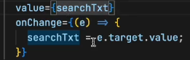Now, will this thing works ? It wont work like this as well, So how to make this work, So I’m trying to say is Local variable like (searchTxt) is not preferred in react.
* **But if I need to maintain a variable that changes itself, then you need to maintain a variable that is a react kind of a variable.**
* **Now what is a react var? It is a kind of STATE variable, So every component in react maintains a STATE, and you can put your all the variable into the STATE, and everytime you’ve to create a local variable you create a STATE inside react.**
* **Now, Let’s Know what is STATE in react?**
* **Now,** Suppose I’ve to create a local variable like searchTxt, then we will create a with something known as **useState hook, Where** does it comes from ?  , so such varaible are been created using useState hook, Here hook are nothing but kind of like normal funtions, at the end of the day hook is a nrml function. **Where do I get this function from?** Well I get it **from react , who wrote this, FACEBOOK developers. So, useState is use to create state variables.**
* **Now, How do I use my state variable ? SO, ** this function returns a array, and the 1st variable of you array is the variable name  and the searchTExt is a local state variable.
* **These hooks gives** some functionalites, there are different types of hookes that we use across our live course, one of the such important hook is useState hook, this is used to create a local state variable.
* **How** to use this var, we can use it like a normal variable.
* **How** to give a default value for our var, you give it like  this. Also if you want to modify your varaibel then directly you can do that, how to modify it then? Well useState gives us that function to modify the var, good practice to write setVarname , after this u don’t do searchINput = value; u do  or i.e., . Now go and see it will work fine. What ever I write it is getting updated in my local variable
* In angular js we got 2 way data binding
* So, in react it isn’t why it is a good thing, cause your app **becomes unpredictable**. i.e., you may use this var in so many place, so for what we are been changing it its unpredictable. And it is not good for optimization also
* 

It is normal JS destructureing

* **React primarily supports one-way data binding, meaning data flows in one direction from parent components to child components. However, you can achieve a form of two-way binding in React using state and hooks**
* **Very Important Interview Question -> Why do we need state variable?** Generaly if you’ve created a var, and presented in the ui, and with some click you want to update the var, but such thing doesn’t happen in react, react wont rerender it will just print the code saved value, To do that, react says every time **you want your variable in sync with the UI, you need to use your state variable.**
* 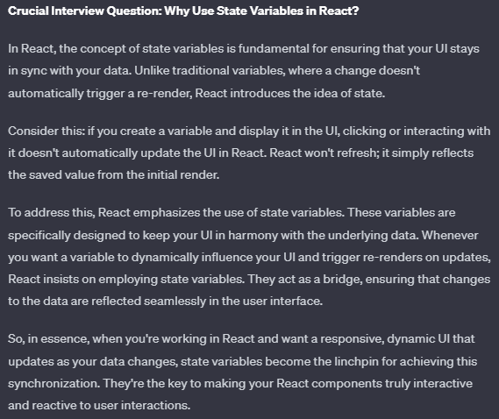
* **Try** creating a variable, i.e., when clicked it updated to true value,  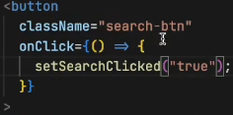

With this the UI gets changed, and get updated. Now let’s understand how it is being done. Now when u create the variable state, the react is keeping track of it, now when ever my var gets updated my whole component get rerendered, react is jst destroying the body component and creating the body once again, and it is happening once again.

**Reconsilation is happening here. React is very smart it will just rerender the h1 tag,** React just rerender that portion of your dom that is why react is fast, it using diff alaogrithm.

* **Let the search work,** when type it, let the rest filter out, the thing is when **clicked on the search buttion need to filter the data, the restaurant list**
* Let’s create a function and filter data, after filtering we’ve to update the list for that, we require STATE’s. create a state variable by default the data should be assigned to dumy data right, yes  , now use your restaurants it will work, with map as well , it worked. Now if I pass with filtered data, will the list changes? YES So what I will do is modify the local state variable.
* I’ve to filter the restaurant list using the input I get, and send it to the function 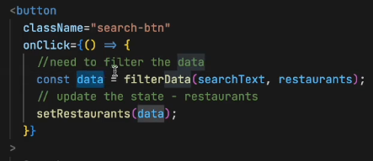then I should be implementing the function which does such work, which give me filtered data.
* 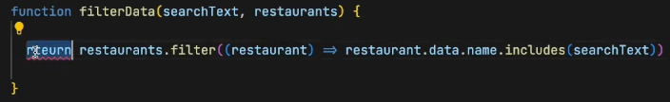
* Now try to run it, it will work.
* **HomeWork:** Do, the toggle thing that true/false.and answer this 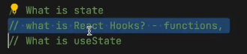 then also restructure your folder then play with export and import, also clear your understanding in onChange(e) on ‘e’ . Also find out empty search why it did not work make it work.

**HomeWOrk ReadOUTS:**

**What is the Virtual DOM?**

The virtual DOM (VDOM) is a programming concept where an ideal, or “virtual”, representation of a UI is kept in memory and synced with the “real” DOM by a library such as ReactDOM. This **process is called**[**reconciliation**](https://legacy.reactjs.org/docs/reconciliation.html)**.**

This approach enables **the declarative API of React**: You tell React what state you want the UI to be in, and it makes sure the DOM matches that state. This abstracts out the attribute manipulation, event handling, and manual DOM updating that you would otherwise have to use to build your app.

React, however, also uses internal **objects called “fibers”** to hold additional information about the component tree. They may also be considered a part of “virtual DOM” implementation in React.

**Is the Shadow DOM the same as the Virtual DOM?**

No, they are different. The Shadow DOM is a browser technology designed primarily for scoping variables and CSS in web components. The virtual DOM is a concept implemented by libraries in JavaScript on top of browser APIs

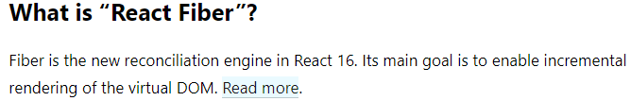

React Fiber is a fundamental rewrite of the core algorithm used by React to update the user interface (UI). It was introduced in React version 16.0 as a new reconciliation engine. The term "Fiber" refers to the internal data structure used by React to represent the components in the virtual DOM.

The main goal of React Fiber is to enable incremental rendering of the virtual DOM. In the context of React, reconciliation is the process of determining what changes need to be made to the DOM to reflect the updated state or props of a component. Incremental rendering means breaking down the rendering work into smaller chunks and spreading it over multiple frames. This allows React to better prioritize and manage the rendering process, making UI updates more efficient and responsive.

Key points about React Fiber:

1. **Incremental Rendering:** Fiber allows React to work on rendering and updating the UI in smaller, prioritized units. This means that the rendering work can be interrupted and resumed, allowing for better responsiveness and perceived performance.
2. **Prioritization:** Fiber introduces a priority-based scheduling system that enables React to prioritize different types of updates. This is crucial for ensuring that high-priority updates, such as user interactions, are processed quickly while less critical updates may be deferred or canceled if necessary.
3. **Concurrency:** React Fiber introduces the concept of concurrent rendering, which means that React can work on multiple tasks concurrently without blocking the main thread. This is particularly beneficial for applications with complex UIs and interactions.
4. **Better User Experience:** The improvements brought by React Fiber lead to a more responsive user interface, especially in applications with dynamic and frequently changing content.

In summary, React Fiber is the internal engine of React that powers the reconciliation process. Its incremental rendering approach, along with prioritization and concurrency, enhances the efficiency and performance of React applications, providing a smoother user experience.

**Guide on Reconsilialtion** <https://legacy.reactjs.org/docs/reconciliation.html>

process of reconciliation in React, which is the mechanism by which React updates the user interface efficiently in response to changes in state or props. The generic solutions for transforming one tree into another have a complexity of O(n^3), making them too expensive for practical use.

React relies on a heuristic O(n) algorithm based on two key assumptions:**Elements of different types will produce different trees. Developers can use the key prop to hint at stable child elements across renders.**

**Diffing Algorithm:**

* When diffing two trees, React compares the root elements.
* Elements of different types lead to a full rebuild of the tree.
* DOM elements of the same type are updated by modifying only the changed attributes.
* Component elements of the same type update the props of the underlying component instance

**Stability, predictability, and uniqueness are crucial for keys. Unstable keys, like those from Math.random(), can lead to unnecessary recreations and performance issues.**

The goal of React Fiber is to increase its suitability for areas like animation, layout, and gestures. Its headline feature is **incremental rendering**: the ability to split rendering work into chunks and spread it out over multiple frames.

Other key features include the ability to pause, abort, or reuse work as new updates come in; the ability to assign priority to different types of updates; and new concurrency primitives.

[**https://robinpokorny.com/blog/index-as-a-key-is-an-anti-pattern/**](https://robinpokorny.com/blog/index-as-a-key-is-an-anti-pattern/)



**Think about how much value you give to the company, by haiving that stack**

* **Learn to negotiate for the salary**

**8. Exploring the world 02-02-2024**

* Last class we tried to build a food ordering app like swiggy, also learned about config driven UI, it is a big configuration or a json object is been send from backend most of the times, or u can keep it hardcoded. Any config can power the UI.
* Revision on hooks, states (for syncing ).
* **Why is react fast? : virtual Dom , reconciliation, diffing algo, fibre architecture.**
* How **does reconcilitation process works?**
* With diffing algorithm, two tress been compared the old and updated one, the diff is updated in the virtual dom a
* **React Fibre is the new reconciliation algorithm**.
* Well what is virtual DOM, we know it got a representation of tree, but at the end it a javascript object.
* The react **is FAST because of it’s fast DOM manipulation, it is the most expensive operation in the UI state. IT is done because of the super powerful diff and fibre.**
* **We use useState variable to make our variable in sync cause rect does not maintain a sync with normal variable, so useState hook provide us the local react variable**
* **Diff Algorithm is the core of react**
* **We** consider {} while importing useState cause it is named export
* **React** will keep track of such variable only  these state var
* On button click we can update the title, using setTitle 
* While doing this, consider your inspect window, and observe the code, will be able to see that only the title h1 tag get’s changed. Here’s where the reconciliation process ticking in .
* Write a console.log and observe you see that, after click in the button the console again prints, **you see that it is rerendering the whole component.**
* In last class in the search box if we type text, then when each key is being pressed the react is rerendering every single time in such fast speed.
* Every UI change requires State, suppose if I don’t want to change any thing in my react then I can use a local variable

**Now let us try to make his thing with actual data, such that not limited to local data, rather let’s explore the world**

* Such that, will be taking to some other API the other world, which our application does not know.
* **Let us talk about important concept which we use in our industries : MICROSERVICES**
* **When** you’ve to build large application like swiggy/uber/amz do you think there is only one react project which is working behid the scenes, It is not possible. Guess how many microservices are their inside uber there are 100s of them.
* **What is microservices:**
* Way back, there used to be a single big application 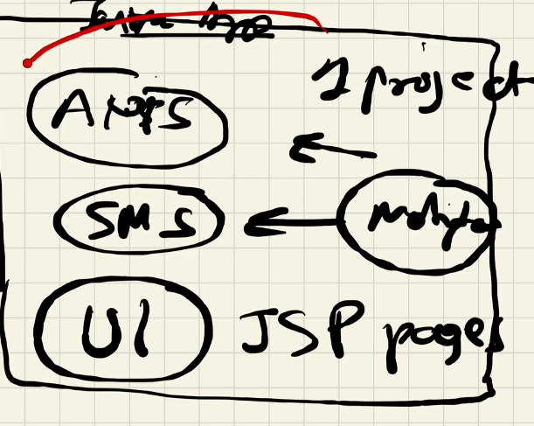
* Every thing used to be in the same project a java project, how we used to deploy **we used to build the whole application to change one button, jst for 1 but change used to deploy the whole java application**
* **This architecture is known as monolith architecture, it got its advg but world is moving towards microservices**
* 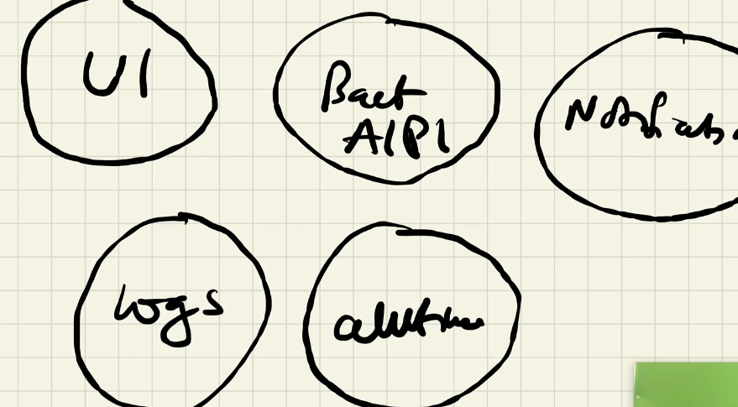Now, in microservice, instead of having just one project will be having small small diff projects, **also known as separation of concerns**
* **Major adv of microsercies:** Easier to test. The best part is you can use different techstack here, java->bcnkd, notification->pythonscript, log->pyth, UI->react, auth->go lang etc., That is why big companies use everyting.
* **In uber most of the bcknd was written in GO LANG.**
* **You know how swiggy have been build it is** using that dapi
* **Now tell me where this foodApp lies in?**
* **It is the UI microservice that we are building**
* **It is one UI project, basically we are building that is deployed in swiggy.com**
* **Now how this applications are all connected?**
* Different port is mapped to
* All these are deployed to diff ports but the same domain name
* Now will be exploring the world, the world for UI projects is exploring other services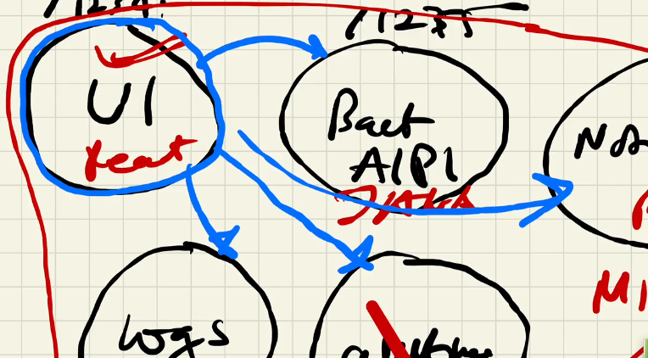
* **Now tell how do we explore the world in JS?**
* **It is fetch, promises, ajax etc.,**
* *Fetch is available to us through js window object, it’s a browser API, super power given to us*.
* Let me tell you one **thing where should I make my API call ?**
* **Basic concept even experienced react dev don’t know this**, if I make it insider the body comp, as we know on any state change react rerender the component. Therefore placing the API call there is not good, cause **it will fetch every single time**.
* 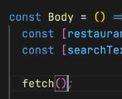**this is not a good place**
* **The very good way to call an API inside our body.**
* **Let know the feature we are going to build**
* **The feature Is as when our page loads it used to call an API and fill the data.**
* **So, lets check the good way to handle this in react**
* **There are 2 ways,** 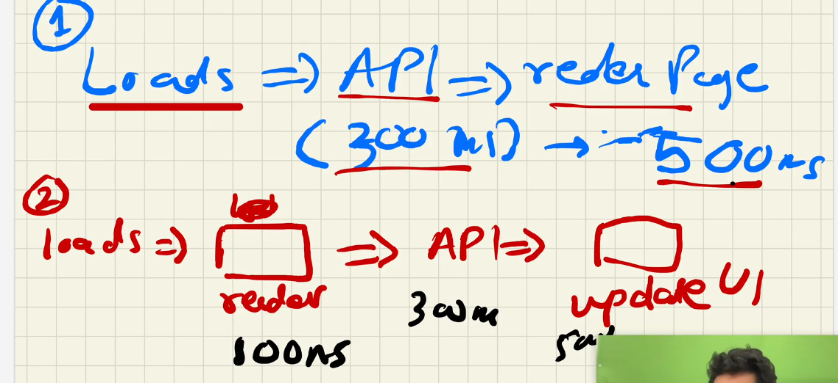
* Which **one is the best way? Why 2nd is the good way**
* Because of **the user experiencec, the page** is **availbe fast, than that of 500ms**
* In React we generally we always do like this.
* In react it always tells us to do somethig like this, and it has given us a functionality to make this happen, It gives us the access of 2nd most important hook it **is useEffect**
* Jst like useState, the useEffect comes from react library
* **W**ell useEffect is a function and you call this function by passing another function to it, it the callback function, i.e., it is not **called immediately it is called whenever the useEffect wants it to call**, and **react make sures that it call it at a specific time the time is**
* 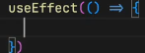Whenever our component renders and rerenders, whenever it rerender what happens is 1st the code of this function is called and after every **render,it will the function we passed inside the useEffect. And when will my component render, there are 2 times**
* **1 is when state changes or my props changes.**
* 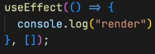But we don’t want to call it after each rerender, that’s the bad wa**y right, SO, pass in a empty dependency array to it.**
* **Now,** Suppose I want to call this useEffect only when searchText changes! Then will pass it in dependency array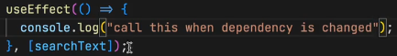
* **Try** this it will call on every searchText update.
* **If** it is not dependent then it will call only 1s, because it is not depended on anything. Hope this get cleared about useEffect.
* **Now lets play with it for all ans cleareance**
* Let it be dependent on restaurant change, check it out
* Now if no dependency then when it will get called once, before render or after render ? also try this what will be called 1st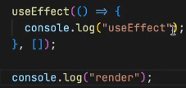 render or useEffect ?
* So, it will call render 1st then after initial render useEffect.
* 
* 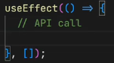**Now we got our answer, when should we be calling our API, it is using empty dependency array.**
* **How do u make a API call?** FETCH
* Let’s try to fetch swiggy’s API 
* So, the call happens asynchronously right, so should we use promises or asyn await.
* Let us use asyn await, it is a good way. One and same thing, but asyn await is the most preffered way.
* 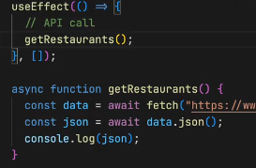It is giving error, cant access who is giving it is it swiggy ? the browser is giving these error, it says from localhost to some api,you can make it.
* To modify this, there is a plugin named Allow cors. If you don’t know watch the cors video <https://youtu.be/tcLW5d0KAYE?si=aBPQAc6CGt7n2vE->
* It worked, and we see the json data in the console.
* Even after updating the state, we can see that the api is not being called once again.
* **Now, we** can use this data, now we don’t need the restaurant data we got in our constant file. Will update the restaurant state variable
* ** this is how we call in from getRestaurants fun itself.** But this practice is not good such that, what if my data was not here it wil break.
* **We’ve** to do optional chaining 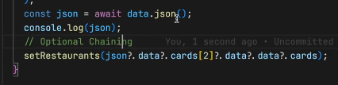
* It will work, you can see new restaurents in the UI, this is amazing about react, the sequence is, 1st the state var contains the old data, it get rendered then the api call get executed then the data gets fetched then the data of state var get updated then again the component gets renderd.
* When you reload you will be able to see the change.
* Let’s try to watch it let’s debug it from inspect
* But debuggers and run and let us see what order do they happen.
* Now when you are trying to lead the page, it is not good, as we see it. So work on it, also consider watching what is swiggy is doing, when u reload it’s page. It’s amazing the way it is
* Earlier there used to be loaders, now psychologist figured out let us show them empty boxes, cause our eyes don’t hurt, there is no sudden change, **this is some UI design principlal it is called shimmer effect. Every cmpny is following this effect.**
* **This is shimmer effect.**
* **Take this as a homework you should be showing a shimmer UI, in you app.**
* **Now, where do you will be fitting the shimmer effect ?**
* **How do you render your shimmer effect when data is not called**
* **One more important concept, the last concept today I want to teach in the class which is known as Conditional Rendering.**
* 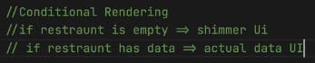i.e., you’ve to render eather the shimmer UI or the nrml UI.
* Psueido code
* Let’s make a shimmer UI component, As we what is everything in react -> it’s compnents
* 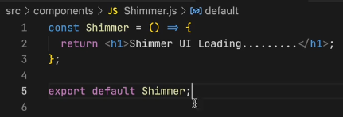**will be using ternary operator**
* 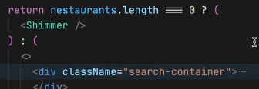**Have your curiosity in you and consider debugging and exploring the inspect**
* **You** see, the search is not working here, cause of no data, also because we have changed the layout of the data. Our restaurents get filterd out.
* **Now let’s** keep a copy of restaurents and change the other one to filtered restrautents 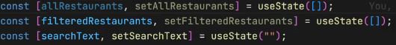
* **Now, when I call the API, I set the allrest var,** when you do this, it will give error , Therfore, for the 1st time let us make both.
* 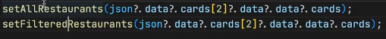
* **Also** change here basically the shimmer is only shown when there is no data, why filterres, why not all res, cause you are mapping your cards from filtereRes.
* **Now** let us try to use search.
* **After** searching one, and getting the res, if you again search something, wil it get poped up ? YES,
* **When my page loads it should be having all restaurens, 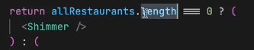, When we rendering It, it’s givng error.** 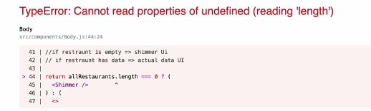
* At that span of time, there is nothing like all restrauent
* **So, how to avoid rendering a component?**
* You, can using optional chaing as well as, you can say that when you are rendering  or 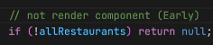 **Will also be doing for filter restrauent** 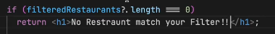
* **Now, you know about it make your UI smoot**
* **Do this homework:** 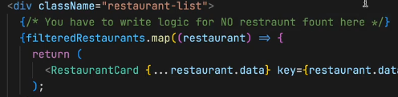
* **Considering doing this:** 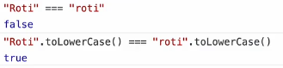
* **Always** remember to put optional chaining
* **Now**  let’s try to build header containing login and long out
* 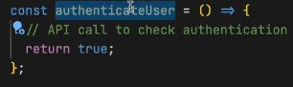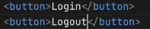should I be showing two login buttons, No right so let’s do it.
* Suppose we got a authentication api, now let’s build function for this.
* 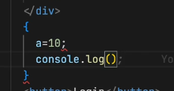One person asked this question can we write this way, can we include js this way in our react code. The answer is NOOOO
* SO, the crct answer, is any JS works over here but only a JS expression not statement.
* Same, way writing if is not valid it is a stmt, where as ternary operator is an expression, so it’s ok.
* 
* **Now,** what if, when we click it, then it should change the button itself in the UI and show me the other button.
* **For** that we’ve use state variable. , will the passing of true works here, or is that is taken as string, well in the expression we can have it.
* 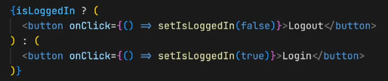
* **This** can make a toggle effect.
* And here the concept **of reconciliation comes into picture.**
* **So,** when someone ask why your app is fast, then you can say, there are a lot of things making it fast, there are bundlers, which does minification , trans.., removing console.log, doing image optimization , and parcel is the beast, and we also have in our application REACT, and virtual Dom , which has reconsilation , diff algo, Dom updates are don very fast. **This is how you’ve to explain your interviewer like this.**
* Where do you think that diff algo is written in react or reactDOm library ?
* The answer is, Diff algorithm is core of react it is written in react’s core. And the DOM updates happen via reactDom, also the div algorithm works the same way in react native.

**Now, Let’s wrap things UP.**

**Homework:**

* built the login logout button
* make your search work,
* explore the world
* , handle shimmer,
* handle edge cases
* , make a loading screen,
* you’ve to do early return,
* DO useEffect
* Also learn this why do we do this twice, data.json after our fetc 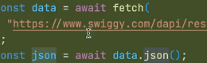
* Read about microservice and monolithic arch

**Recap:**

* We read about useEffect, a diff hook. Be perfect In this 2 hooks.
* We make our search work for upper and lower case.
* Early we had 1 res, now we’ve 2 list of res state variable
* But we are rendering-> we’re rendering filterdRestr in the resd function.
* Then why allRestrauent req? TO SEARCH to filter
* We learned about dependency array.
* Then we made a API call also made async await fun
* **Then** we set our setallRest and setFilterres, then did conditional rendering
* **We** also studied microservices, monolithic services.
* **We’ve** build small mircorservice UI.
* **ALos,** studied how these are connected
* **Also, studied** good way of rendering when using API

**Chp 9: Finding the Path 05-02-24**

We learned about useEffect hook in the last class, what is its use?

Using API is jst what we’ve done in it, well basically useEffect is a hook, which react gives us which is called after the component is rendered.

It Takes, 2 parameters, 1 is callback function and the other is dependency array.

* The callback function will get called after the rendering.
* The useEffect can even get called without passing 2nd para, 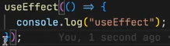 If we don’t pass anything the useEffect get called after every render.
* If **[], then onlt be called once after the 1st render it mean** it **got no dependency**. And if I put searchText, then it will be called everytime my searchText changes.
* 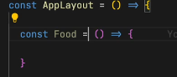1 more important thing react doc says that**, never create a component inside a component.**
* Never do this:
* Such that keep it on the top, level. Cause of rendeing, if our apps get renrded then ur comp get created how many times?
* **One more important thing about hooks, also never ever write a useState inside if else**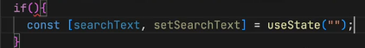u don’t’ve to do this.
* **React does not like inconsistency, cause** react don’t know it will there are not, i.e., it will be available for the app or not.
* It is **not a optimized way, react** likes concreate things.
* Never do this, and also u never get a case to do this, hardly .
* Also, never write inside a for loop.
* **useState is a hook that react gives to create local state variable inside your functional components. SO never use useState outside your functional component.**
* Can **I use more than one useState inside my functional comp, YES. According its usecases.**
* If you want to keep local images then you can do this, by creating a folder named assests. Then keep your img in it.
* Also, you can consider the images from cdn, when u r building an app**, cdn images are great place to host your images your homework is to learn about this.**
* When we put images into cdn we can put optimized imgs, cause from there no optimized images comes.
* Did you implemented the Shimmer effect? NO.
* Lot of u implemented using react shimmer, using npm package.
* Don’t use it, it is such an easy task to create. No need of external package for this.
* For everything you should not be importing packages, be causious about what you are importing.
* Npm is-odd package. Such an easy fun, helps to say num is odd or not.
* **Now, let’s try to create a shimmer. We’’ve to create a similar kind of view with dummy cards.**
* 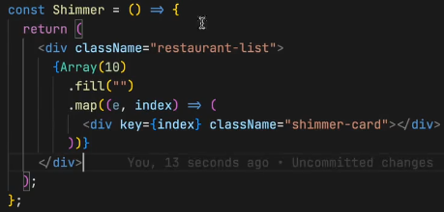Simply we’re creating an empty array of 10 and mappig it to div
* Consider adding the key to it, for nw I added index.
* The thing is when you’ve to do tideous work then consider going for external libraries.
* Like **let’s say you’ve to build forms which contains** lot of constraints. Then you can consider using npm pckg, like formik
* **Formik is a great library.**
* In this lesson, will be learning and **creating lots of routs.**
* Such that, let us t**ry to make diff pages for Home, contact, About etc.,**
* For this will be **using a npm package a library, it is a very popula libr, and a standard lib now and ever one uses it.**
* **It is REACT ROUTER.**
* Will be installing through our terminal : npm I react-router-dom, we can see in package.json
* Let us start using it.
* Will build about page, contacat page and see how routing works.
* Shortcur for comp, rafce for a component.
* Always try to make your component from scratch, make a habit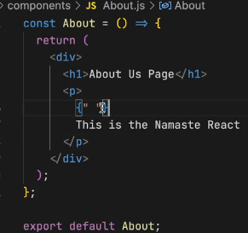
* Now, I want to create a route, i.e., when I write /about it should display about page.
* For this I’ve to create a routing configuration.
* Will be importing a function: createBrowserRouter from our new pckg. It will help us create routing.
* How do I create routing now? , Now when we use this function, we’re creating a router. It takes in some configuration. This is the place where I will define what will happen if I load my /path. Now I will create routing configuration
* Some are saying why r u not using diff types of router, there are multiple router that we can use, that has there own way’s of creating routes. Got to the documentation and read about all routeres. For now we are using CreateBRowser Router it is the recommended router for all react router web projects.
* Now for the configuration inside the function, will be giving path and in the element will will mentioning the component.
* 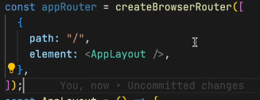Also, you should be keeping this fun, below your applayout component, i.e., it should be in sequence.
* Now, import about comp, and try to do same as you did in above.
* 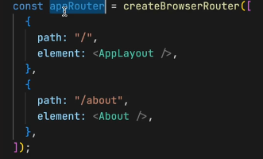Now, do you think that this will work Nooo
* Why? Because we need provide this approuter to our app.
* How do we provide this?
* There is a component, RouterProvider, coming from react-router-dom.
* Now, in render we are rendering our APplayout do we always want to render APplayout ? No, we want to render according to our path. SO what we say is that render my RouterProvider by passing some config i.e., router={appRouter}/>
* Now what ever the rout will rnder it will render according to this configraion.
*  this is known as props, passing.
* Everything is available in documentation.
* Run it you see the working.
* If you try giving wrong path, then the library is giving us a good UI for the error, it is not showing any error in the console.
* This is something a great user experience.
* Now, let us create **our error page.**
* E**rror page is also a component.**
* 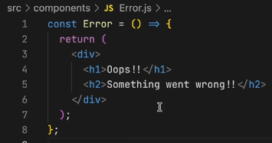
* Pass this error, component in the router configuration.
* Now, will be giving errorElement.
* 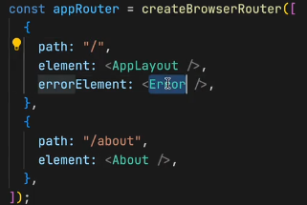**now if lets say we want to display some more information about this error, HOW?**
* **React-router gives us, useRouteError.**
* It is a hook, which react-router-dom gives us. . have a look,
* Consider **display what you want to**.
* This was the routing session, take break will be **learning, nested component, nested routing, and dynamic routing.**
* Now, if want to go to about page by clicking it, what should I use ? some saying onClick and some anchor tag.
* The problem **with the anchor tag is it will refresh the whole page.**
* **Building a single page application.**
* **This concept- SPA: with single page application our app does not reload it is not making network call when we are changing pages.**
* **There are two types of routing.**
* **1. Client side routing and 2. Server side routing.**
* In **server side routing it is the way where all our pages comes from server.**
* But in our applications, **in our React application will be building client side routing. i.e**., when I click my about page, it will not make any network call for it**. Don’t’ve to go to server and fetch Cause all our compoenets are already there in our code**.
* 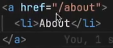When we do this it will reloade the page.
* 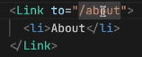Now react-router-dom helps us here, without reloading the page, it give **us something known as Link**, import it from **router-dom**, will use our link exactly as we did for our a tag.
* Same **can be done with Home**.
* **When you go on checking in the console, you see an anchor tag. Why? At the end of the day, Link uses anchor tag.**
* **Rect-router-dom is keeping track of all these links.**
* **Now lets work on Nested Routing.**
* So, the problem with my app is, when I open my about page, **where is my header and footer?**
* Now, the thing is I **want to keep the header and footer intact.**
* Will **have to change our routing config.**
* What I want is something like this, 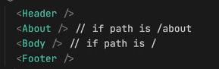I will have to change my confi some thing like, 1st I will have to make **about as children of AppLayout. For this, will be using, children**: in our config, It will take the same configuration as the path do.
* 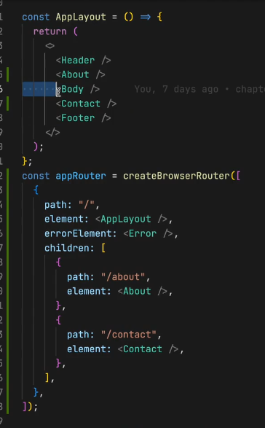This way
* Now let’s create a contact component, and also will be adding one more children as contact.
* Will this thing works, well we’ve put all of them together, every thing comes in our page.
* This is not the right way to do it. If the page is /about I want about page if it is /Contact I want contact page.
* 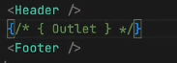**We’ve want such layout, we want the header and footer to be intact, and the changes happens in outlet.**
* 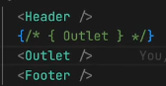**React-router-dom, gives us access to something known as Outlet.** It is a component
* **This outlet will be filled by my children configuration.**
* **SO the thing, is all our children will go into our OUTLET according to the route.**
* **/about /contact it gives but the body is not available,** **for that I will need my body compoenet as children in the config.**
* **Now you can see that working, header and footer does not go anywhere while you switch between apps.**
* **Now consider cheking the inspect, you will be noticing that header and footer are intact.**
* Our reconislaiton algorithm exactly knowns what need to be reloaded.
* **Html doesn’t recognize outlet.**
* Consider playing with this
* Will now learn a important co**ncept known as Dynamic Segment.**
* You can observe in the swiggy website, when you click the restaurant you see it is changing dynamically from restaurant to restaurant.
* **This id is dynamic.**
* Now let us try to build this cool thing.
* Let’s build a component, **named RestaurantMenue.jsx**
* 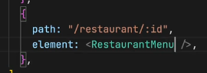When I clikck some hotel, it should take us to that page.
* 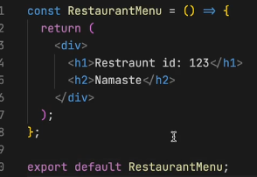When you add that path, it will work.
* **Now let us try to read the id from the url.**
* 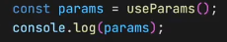**Import useParams from react-router**-dom, and use. For reading id, I can destructure our params
* 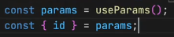both ways are same.
* **Try going to some hotel in swiggy and see the API call,**
* You will be **seeing all the restaurant details**
* **Now let us try to take those details here, using useEffect**
* **In that we pass a callback function and dependency array, also will call a asyc function, async is to handle our promises from that function.**
* 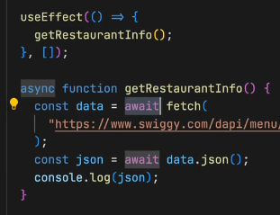Will be having our api data in console.
* **Let us try to render this in our page.**
* **Now how to render this.**
* **Will be using useState for this.**
* Don’t relay on autoImport, you should be knowing from where it is coming.
*  and call setRes from the getRes function .
* Now will display the resInfo, will be using same url for img, import from costants.
* **Will’ve to iterate on this.**
* We are doing this, cause It is converting our objects to array? Read about it and understand.
* Always **remember when you r using map, use key.**
* We’r getting an error, cause at initial render, our restaurant are not available so in useState don’t **pas {} object, pass null,** cause as it is an empty obj and still I’m reading a lot of things form that empty object, also **write optional chaing there**
* 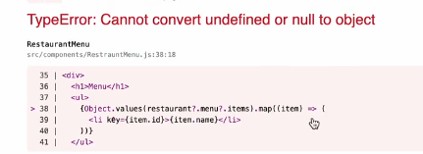**then we can also do a early return.**
* 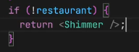**will be showing shimmer**,
* Or **can also write as ternay** 
* 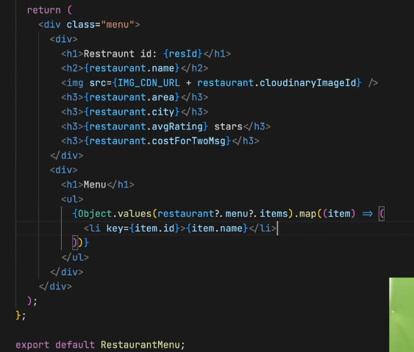Now, **when I try another id, we are seeing same restaurant, it is not loading another res, cause we’ve hard coded our API**.
* **I’ve to pass dynamic id and add this to the url.**
* Listen it carefully, when we write our code, in modular fashion then we can reuse it a lot.
* Now, this is the power of react-router-dom.
* Now, let’s make this happen i.e., **when I click on some res, I should be able to land on it.**
* We’ve **to link the resMenue comp**
* **In our body, we’re mapping the resCards, let us wrap it inside the Link,**
* 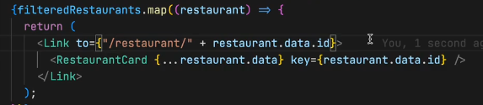
* Let me tell you on thing, the key should be in Link, as we are mapping our **link component, the key should be in our link comp.**
* 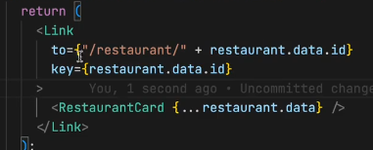This way
* **Now it will work, when you click on it , it will redirect to our resMenu comp.**
* This is very important thing, you homework for today is you’ve to make everyting dynamic in you app, routing should be proper, you **should be able to exactly know about nested routes, dynamic routes, how we handle error in our route, how do we create a error page, lots of things we did today**.
* **Let’s recap:**
* I can create multiple useEffect.
* I should not write a useState inside our if else.
* Also should not in forloop.
* Showed how to import image in our app , assets/img
* Also told about how to import shimmer, and don’t use external lib if not needed.
* For form building the lib was, formic. It is very helpful
* ExtraHomeowrk: Build a login Page, when u click on it it should take us to the Body page.
* Try to use formic, are read it’s whole documentation.
* Then we learn about routing, we used react-router-dom lib.
* We’ve used createBrowserRouter, it takes and obj or array?
* It takes, array of configuration.
* Each andy every obj had a path and element, also learned about having errorElement.
* After making that configuration How do you provide it, we use routerProvided.
* Tell me a component where you fill in ? It’s OUTLET it comes from react-router-dom
* Whatever children that we make they go insider our outlet
* Does he seq of children matters**, No**
* **We** went on creating a Error Component.
* **To get** the error, we used a hook named, useRouteError
* **How to** put this error page into the config, we used, errorElement
* Now tell me how do we read our dynamic id, from the url
* useParams hook
* We are writing our code, in a proper way, that is why we’re able to reuse it in a proper way. The shimer, the cdn url
* **Make a comp for every logical thing, help your code modular, readable, maintainable, reusable, testable**
* We again fetched data from swiggy API
* Try using optional chaining. Be careful.
* Link component is used, behind the scenes this link component is using Anchor tag.

**10. Let’s go Classy 11-02-2024**

* Today we’re going to study class based components
* What **we will be learning today is goining to help you a lot in your interviews.**
* **React initially started with class based component**. There was no concept of functional comp, and no hooks, and it was very tough, but we were coming from jQuery.
* The concept was same but the code, we used to write was diff.
* The code was not clean thing were messy, with class comp, and it used to be very big, more code, less maintainable.
* Now we’ve enough knowledge, we can understand class based component.
* Class based component are no longer used, If you are creating project, u wont be using class component.
* But why to learn, cause companys got older project which may be written in class based comp
* Also, in the interviews many questions come from class based component only so have your full attention on this lecture.
* 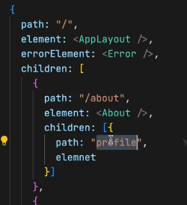Last class we studied how we can do routing, nested routes, also try to read about other routers whos doc is available, now lets go into code of class based component.
* Suppose in our about page, I want to make a profile section, how will you mak a route /about/profile ?
* **Will be using children of children.**
* In children don’t write /about/profile, you **should be writing relative path.** The other way might work didn’t tried it.
* Consider writing element, and create profile.jsx compoenet.
* 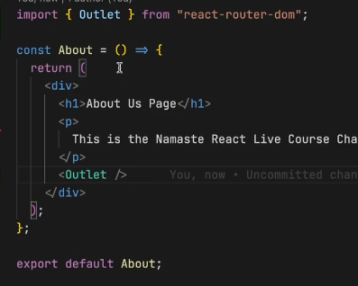, if I write this way then it means localhost/profie.
* After doing this, when you go **to /about/profile you will seing nothing. Why? Did you forget the basics, cause The basics** are the childrens are always renderd inside the an OUTLET. Now where should I be creating my outlet, Outlet should always be created in parent, the parent is ABOUT, so create there. This will work.
* If I want my **profile component whithout using an outlet here what will I be doing, We can jst directly import our profile component.**
* **Now let us move to writing Class based component.**
* Let try to build this component as profile component ProfileClass.jsx
* 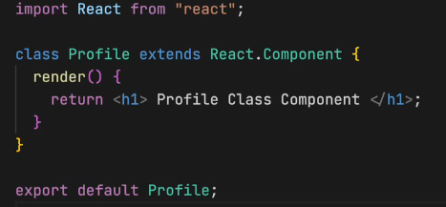Tell me what Is functional component at the end of the day?
* It is a normal javascript function.
* Same, the class based component is normal js class.
* You’ve to say js that it it’s not a nrml class Therefore you extends, React.Component. It comes from react.
* **Note: The most imp part of a class based component is your render method.**
* **You cannot create without render, it is the only mandatory method in you class based component.**
* In nrml fun comp, it is function that return some jsx. And here **now the render method return some jsx.**
* And we will export our class as we did in fun
* If I use it in my about, then it will work.
* Also but functionalComp, and will try to send props, and receive using parameters of comp. props.name
* Now **How do I pass these props inside our class Component**.
* So in class you get **with this.props**, when you’ve class based comp u will be having lot of use **of this.**
* **this.props.name**
* Let know what did react did?
* React basically is tracking you class, now as it is a class based compoenet, **when ever there is a props change or state change in our classs, I need to rerender it.**
* It takes **the props, and attach it to the this** keyword of the class
* This happen during our reconsilaiton process, react automatically get this props,
* **can pass props this way in config.**
* Now, suppose I want to create **a state inside a functional component, how do I do it. With import of a hook, useState.**
* **Class Compoenet** also have its state here.
* **We** know class has a constructor.
* **Will’ve to do 2 research question ?**
* 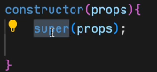**1. Always when you r creating a class based component you’ve to get your props inside your constructor and do a super(props). SO do research Why do we use super, what is a constructor why react is passing props there.**
* **Why I’m creating a constructor, basically constructor is a place, That is used for intialization.**
* **When ever this class component is rendered,** the **constructor is called And this is the best place to create your states.**
* You will create **state var in constructor.**
* ****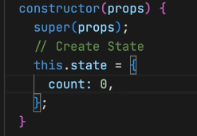 This is how we do it.
* In function we used to do this.
* ****Now how will I use this count?
* **we used this in functional Component.**
* If I **want to create 2 state var, then in func compom, we do the same way .**
* 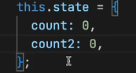But here **we don’t do this way, So all the state variable are created as a part of one object.**
* **React uses one big object to maintain the whole state.** Even in our functional component, react still uses one big object behind the scenes.
* **Now,** let us understand how do we do our setCount ?
* **In funComp, we ** and we can use it with button on onClick.
* 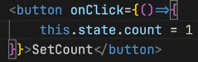**This** is not good
* 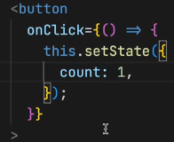**In class based comp, will be using setState,** will be passing a **modiffed obj.**
* **We do not mutate, state directly never do this.state = something.**
* When you do **setState, react keeps track of it, and automatically reconsilaion process sync our UI.**
* 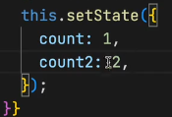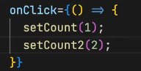For **two state variable in funcComp** we do this.
* In classComp we do this.
* We can update it together.
* In functional compoenet, will update for each and ever variable.
* **New way is bad or good?**
* **Well new way is v v v good , in past** if my state var or 2, and I change only 1 var, then thinking of it how it doing this all?, it is jst **modifiying the partial object that I’m passing.**
* Now, fun is very specific I exactly know the thing.
* **Try to research how the setState is working behind the scenes**.
* When I write my consolelog in functionalComp, above return when will it prints, will it print always I render it ? YES
* **Now if I write consoleLog in my constructor and also, we’ve consoleLog in render Now what will be printed 1st.**
* So, how the react lifecycle works, every class is a lifecycle, every **time in the lifecycle, 1st the constructor is called, then the render.**
* One more thing, where do I do my API call in funcComp ? In useEffect. When is my useEffect is called. After every render. Why it is a great place to do API call? To make our application fast, 1st of all we render whatever we can by the default state, later on we jst updated the state. Its like render update, after updated will it rerender ? YES.
* **Now** let us see in classBased component, here also same patter, 1st we render, then update something. How we do this in classComp **So in classComponent we’ve our constructor, render and componentDidMount method.**
* 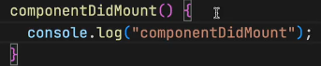**This** is the function **which will be called after my render.**
* So, when ever class based component is loaded in the page, it has some lifecycles methods that is called. The constructor, Mount, render.
* The **sequence is 1. COnsturctor, 2. Render 3. DidMount**
* **Now with you logic tell me what is the best place to make an API call? compoentDidMount**
* 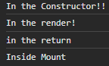**Why we r doing, that many don’t know this, but we know cause we know how react works, 1st of all will render, then update it later.**
* So it is the best place to have API calls’
* We’ve got many such lifecycle methods.
* Now keep your mind inTack, what we’re going to learn is very important thing.
* Pay attention to each and every word I speaks.
* **Let us revise, By creating an About component, as class based component.**
* Rather than extending from React.Component we can also do this.  and directly use Component.
* Next thing Is constructor. And write super(props) this is our research homework.
* Will also be implementing ComponentDidMount.
* And the order will be 1st, **the constructor will be called**, **then rende**r, then **componentDidMount**.
* Best place to make an API call is c**omponentDIdMount**.
* Where do you initialize your state variable, Constructor ?
* Why do we do that in our constructor?
* **Cause, when class is been initialzed you constructor is by default called.**
* Understand what is the 1st thing that will be called?
* 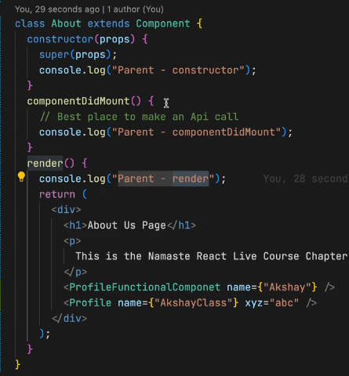1st will be parent constructor, then ­­­­2nd thing will be parent render, then 3rd thing will be child constructor in profile comp, cause when it calls render, then it follows the sequence as we’ve Profile comp, then it goes there and follows the sequence.
* 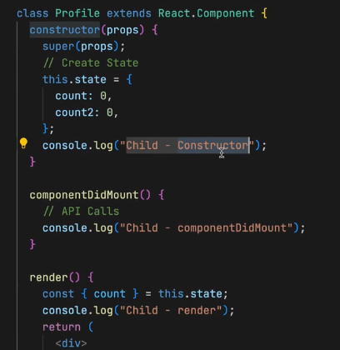**i.e., parent will trigger the lifecycle of children.**
* **Here,** 3rd the child-coonstructor get’s called.
* **After this?** 4th thing is, child render.
* **5th thing?** It will be child component did mount.
* **i.e.,** It will complete the lifecycle of children.
* **Next 6th** will be parentCompDidMount.
* 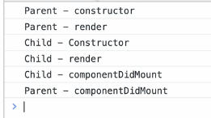**Mount means to Load jst assumeig**
* **Now, What if I’ve two children?**
* 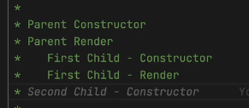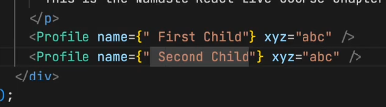 **Till this point ok, now what’s next?** Fist Child Compoenet did mount? I said Yes.
* **But you are wrong over here.**
* The **answer, is nxt will be the second child constructor.**
* **Nxt, will be secnd child render.**
* **Nxt? I said 2nd childCompDidMount**.
* But **answer is 1st componentDidMount., nxt will be secondCompoenet did Mount.**
* 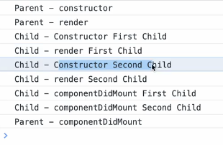**THEN it will be ParentComponentDidMOunt.**
* **So, this is why class based component were very confusing**.
* **Now,** react has become very simplified but this questions are still there.
* 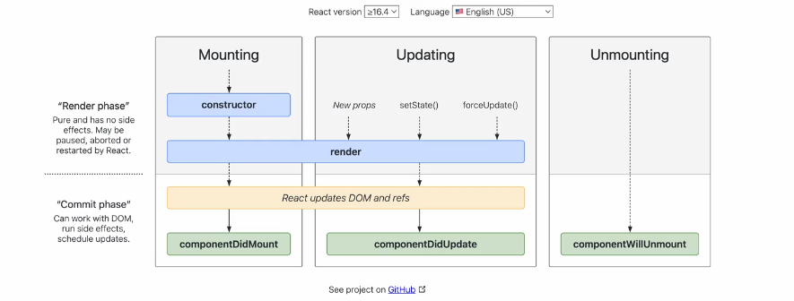**Search React Life Cycle method.**
* **If you understand this, you will never get confusing in you life.**
* **Focus on** the mounting for nw.
* **This** is very important thing now,
* **When** react is rendering things up, it **does it in two phase.**
* **Then 1st phase is the render phase.**
* **The 2nd phase is the commit phase.**
* **What** Happens **Is, 1st of all react finishes it’s render phase.**
* **What we got** in the render phase is**: it includes your constructor, includes ur render method.**
* **Commit phase,** is the phase **where react is actually modifiying your DOM.**
* **ComponentDidMount, is done after you’ve updated the DOM**.
* **i*.e.,*** *after the initial render has finished. After my component is on the browser.*
* ***That*** *is why we see Shimmer effect.*
* **Let understand in the code,** 1st react will call constructor, then render and it will generate the html, that needs to be put into the DOM, Who helps us converting this jsx to html, That’s BABEL. **🎉**
* Now, after this render, we r ready to put things into our dom.
* In the commitPhase react will update the dom.
* **After updateing the DOM, react will call componentDidMount.**
* This **is how the lifecycle works**.
* Now, with this knowledge why there were discripences.
* **When there are two childrens, 1st of all react tryies to batch up the render phase**.
* Ok, tell me render phase is fast or Commit phase is fast.
* Render phase is fast, cause commit phase to update the DOM, which is toufffff
* **React** batchs up things inside render phase,
* **Suppose** we’ve 1 parent & 1 child, parent will call its constructor, parent render, 1st child constructor, 1st child render, Now at this point if we got more childrens then react say’s that there are more children let us complete the render for everyOne, I will commit it again.
* **Cause,** Suppose one of the children making api call, then it started the commit phase, then it will delay the render phase for the second child.
* **SO, it batches up the render phase for the 1st and 2nd child.**
* After completion of render phase, now is the place react will update the DOM, Dom is updated for children.
* **Now, our commit phase starts, in commit phase, 1st child componentDidMount, then 2nd child ComponentDidMount.**
* **And then parentComponentDidMount.**

**Now moving to the new Concept.**

* Let us make an api call, l**et’s make some api call to fetch some user information, lete’s call github API**
* Google, github api user api, get user.
* How, do I make an api call?
* I **will use fetch, this is an async operation so I should make my function async.**
* Now comes the important part, your 2nd research homework
* **We can make the componentDIdMount asyn, we’ve written there , but you cannot make a useEffect async. SO homework is why can I make compoentDidMount async but not the useEffect in functional component.**
* **This is asked to seniors advanced developers.**
* **If you understand this, u understand the internals of react.**
* **IT’s a diff way how hooks are build**.
* After fetching, I will convert it into json.
* 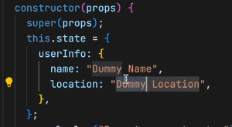How will I put this data into ui, yes I need to create a state, will be creating that inside the constructor.
* Now, how do I push this data, into the state.
* 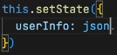this.setState({userInfo: json})This all **is created in profile class.**
* Such that, I had made my API call inside my child.
* 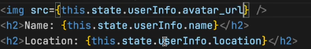Will be accessing it this way.
* **SEE, in** the browser we made an API call.
* 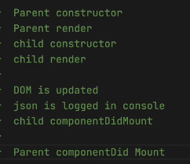**Now** let us see what are the sequence method is been caleed.
* **This is how it goes on doing, 1st the render phase, the update phase, then commit phase.**
* What If **he says that this is wrong.**
* 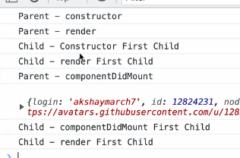**So, what is being happened is:**
* **Parent componenDidMount is called before making an API call.**
* **Cause, as we said react finish it’s render cycle 1st then it goes to commit cycles.**
* **But nw, as the CompoenetDidMount has an API call, this will be called later, as we are using async and it will take some data to load.**
* **The way we’ve written it, it will follow that way, but as we are making an API call in childCompDidMOunt, as it is asyc it will wait for the data to fetched, till that it will call the parenCompoenDidMounbt.**
* **After parentComp, it wount stops over here,** as we got the data we did a setstate, what will setState trigger, YES, it will trigger next render, It will triger the recocilation process.
* 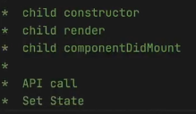**This rerender cycleis known as UPDATING.**
* **Here’s how the children follow’s,**
* After the setState, then this cycle is update cycle, What will happen when you trigge the update cycle.
* **It will render, update the dom then it will trigger another method componentDIdUpdate,**
* I can’ve this as well.
* Mount is called, when? After 1st render.
* **And update will be called after every next render**.
* Now, **think of it’s use in past, it is hectic, to write Mount and update.**
* 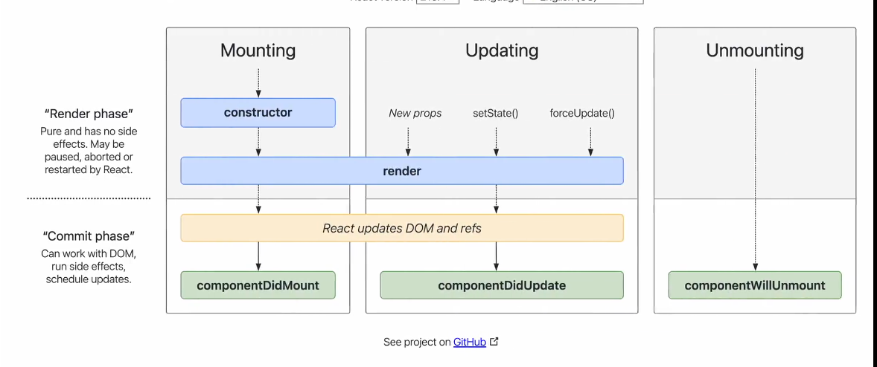Actual react **was this. And 90% of the developers don’t understand this cycl**e,
* Most of them will be confusing.
* There **is something known as unmounting also.**
* A **component mounts and a component unmount also.**
* 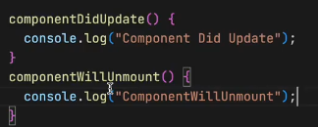When it is destroying it will call this.
* The method called is componentWillUnMount.
* **Now in browser, keep an EYE in the console, when I go to someother page, the compoennWillUnMount get called.**
* **DISCLAMER: never ever compare react’s lifecycle method, to functional component.**
* **Bad habbit they say, useEffect is equivalent to ComponentDidMount. Don’t’ say this**.
* **Behind the scenes, useEffect is not using componentDidMount. It’s new way all together.**
* **After each and every render, my useEffect will be called, thing are different with classBasedComponent.**
* **Here one 1st render componentDidMount, and after** subsequent render componentUpdate will called.
* **Also,** in useEffct we do empty dep array, for once calling in intial render.
* **And if** give some varaiable then every time my count changes it will rerender.
* 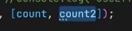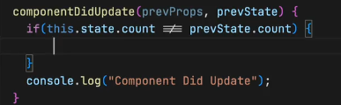**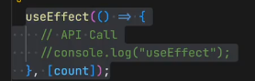If you’ve to do this, then u’ve to write like this,**
* **If more than 1 var, then can write this way.**
* 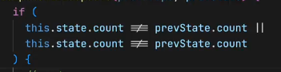**Had to do this way,**

Let’s **do this, I want to do something when my count changes and some other thing when my count2 change. How will I be writing this.**

* **We uses two useEffect.**
* **Where as in class we used to write two if’s stmt.**
* Now also let’s **understand the useCase of CompoenetWIllUnMount.**
* It will be **called when we r leaving the page.**
* Guy’s how many pages, do we’ve -> from day 1 I’m saying it is single page application.
* IT is single page we r just changing the component.
* **There are lots of things we should be clearing when we leave the page.**
* 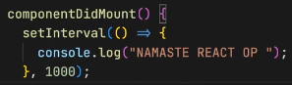 Let us say I got this, setInterval function, now when I’m on page, it will print this each second.
* But guess what if I movie to other component, then also it is printing, which is not expected.
* **And** also if I again go to some other page, then it will strt twice.
* **This** is the problem of the single page application.
* **Cause** When you are changing your page, it is not reloading your page, it is jst reconsilation, jst rendering.
* **So this is the answer, why we need to unmount things.**
* **I will be using clear Interval in componentWillUnMount.**
* **But** how will I reference that interval here, Yes mayuri is write, will be using this.setInterval. this is shared between all functions of this class.
* ** will be using this way.**
* This what you should know, when u r creating a mess u should clear it also.
* 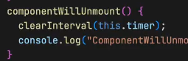
* **Now, friends what will happen if I create setInterval inside useEffect?**
* **It wont stop.**
* **Cause we’r not cleaning things.**
* **SO, now how will you destroy this in your functional component.**
* **So, we can write return function in useEffect,**
* 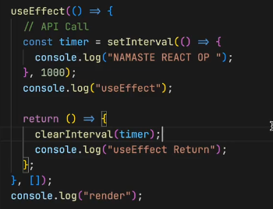**This return function is called when you are unmounting it.**
* 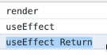**This is how it works.**
* **Your home works is to play everything we did today.**
* **And 2 research topics.**
* **1. Superprops**
* **2. Async compoDIdMount**
* **And in useEffect callback I cant make it async.**
* **React will complaint, find out the reason.**
* **Chapter 8 DONE>**
* **Now we are diving deep into topics.**

**11 Optimizing Our APP 19-02-2024**

* **TO**DAY will be **seeing how to build our custom hooks.**
* **Revision:**
* **ComponentDidMount will be called, not everyone only when there will be update in state.**
* **2 phases.**
* **Batching, when 2 childrens**
* **3 things when compoenet is loaded.**
* **Also, when component has nothing then how many** times update happens its ZERO. So component will be mounter and unmounted.
* **What is componentWillUnmount is used for?**
* **Will be trying to build our OWN hook today.**
* **Well,** why do we build our own hook, why do we need it, when do we use it.
* **1 Great example Is Reusability.**
* **Readability.**
* **Separation of concerns, maintainalbility.**
* **So, generally hook is a function, why we use function, cause we write some logic in it, and to reuse it will be using function.**
* **Wrap up a small logic and can use it anywhere.**
* **Let us understand about the function filterData.**
* We are using it in the button, we don’t care about the logic, also what is the best place to keep our filterFunction.
* If oneMore component used to filterTheData then will be using it. So there should be common place where we keep our utility functions. And import from there.
* **Will be creating a utility folder.**
* **Create a** folder named, utils and create a file helper.js
* 
* **This is how we import, and will be exporting it from the utils.**
* **Now,** if my profile class want to use it then it can use it.
* **Can** use it from a central place without rewriting it.
* **This** makes our code, readable and reusable.
* **Also, this makes** our code more testable.
* **Cause I can** write separate testcases for this.
* **We** also say our code is maintainable cause, we can easily debug it. And can quickly fix it.
* **And hooks,** are also used for same reason.
* **Modularity** means we’ve broken our code into meaningful pieces.
* **Now we got our answer, why hooks are used.**
* **Now let us create our own hook.**
* What is the job of the restaurantMenue Component.
* Showing the restaurant details.
* 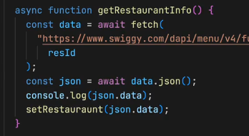We’ve tried to put this fetching logic in it.
* So now the component is doing two **things, 1 showing it other, fetching.**
* Can we extract some more logic from this component.
* API CALL can be extracted
* What we r doing is, we are taking params which contains id, with that id we are fetching the details, and then displaying.
* Let us create a hook that helps us getting the restaurant details.
* Always create a hook with **a use Name infront** it.
* It is react way of knowing that it is a hook.
* Will be creating **useRestaurant.js** in utils folder
* Will be exporting a default export, cause for named exports, if we got more than 1 useful things then we can named export, like we do in helper, and constant.jsx file
* useRestarant will fetch the data and send me.
* 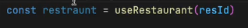This is in general we want it to do
* When I passes resId it return me the details.
* At the end of the hooks are normal functions don’t panic.
* What should useRestaurant return ? return restaruatn data.
* Where it will get the data?
* It will get data from API.
* Now, one more thing u’ve to handle is suppose if, my params changes. My data should also change.
* So what I do is, I will create a state for this hook.
* After that I will fetch data, the logic in the restaratnMenu.jsx code, been pasted here.
* Then will **be returning the state variable.**
* 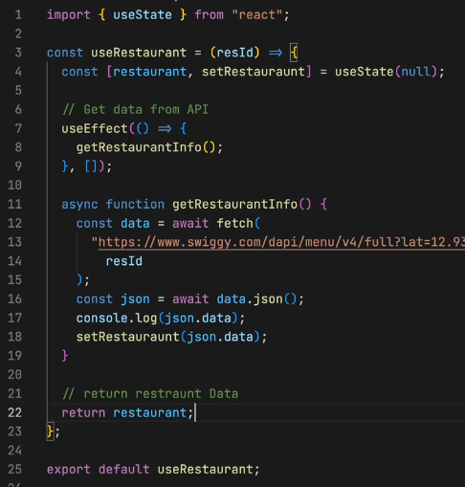
* **This is the custom made hook.**
* **How,** can I make his hook, even more better.
* **One thing, is** I can keep the link in constants.
* Let’s make one more amazing feature, suppose if connection is not good, then it should display u r offline.
* **Suppose** the user is offline then I will restrict the user to click any of this. I will say check your internet connection.
* **Lets create a custom hook.**
* 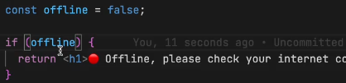**this way .**
* Now how will get to know wheather I’m online or offline.
* There is something known as windoeventonline
* Now, what is I had a custom hook, , which returns me wheather I’m online or ofline.
* Therefore, you’ve to change the way you think.
* If someone asks you, you build like this.
* Will create a util, useOnline.jsx
* **useOnline is basically a normal arrow function, it should return a Boolean value the status.true or false**
* **lets** create a state variable,
* 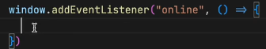**now’ve to** write the logic.
* **In js we do this way. Whenever you are the code inside it will trigger.**
* **How many time I’ve to set my eventListerner : JST ONCE>**
* **Whenever my page loads it should track once.**
* How do I **wite the code, it should write once.**
* **Well I’ve to use useEffect and adding a empty depency array.**
* **I would want some one of you, to make your own library.**
* 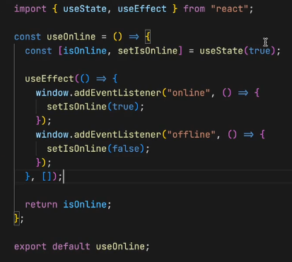**How do I fake It online in the browser.**
* **Ok, so go to network tab and you can change to online, offline,**
* **Now let me tell you one more thing, this is not senior devlopers code.** This is a junior dev code, how do you u make it a senior dev code.
* **It is** cleaning the cache, cleaning the event listeniers.
* **When ever you are going offline, and online our new event listeiner is created. NOOOO, it don’t, in useEffect we’ve empty dependency array.**
* **Ok, now suppose I go to about page, is our event listeiner still there, well yes it is, we jst need it in body component.**
* **So, it is always a good practices to clear the event listener when we go out of our component.**
* **Otherwise our browser keep holding it.**
* **We do that in unmount cycle**
* **In useEffect will write that code in return**
* **When I removeEventListeiner I’ve to pass the same function that I’ve passed in addEventListiner.**
* **For that I will create a sep function outside this. Add pass it**
* 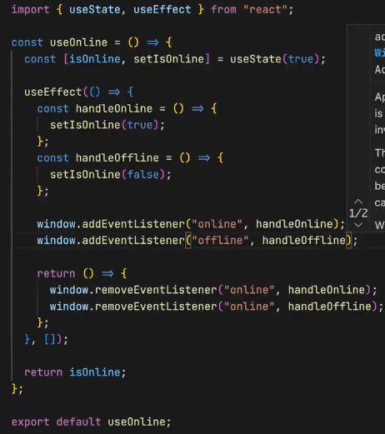 **This is the senior dev code**
* **Let us quickly revise it.**
* **At the login Button if online u can show a green or red**
* 
* **With this way we can create hooks for diff uses**
* **Like, for auth , can also create a hook to use local storage, **
* **U can also take this way, **
* **Try building this stuff.**

**Now let dive to other concept;**

* **In the second chp, igniting our app, what did we studied**
* **We** studied, parcel, babel, npm etc.,
* **What is** parcel it is bundler, job of bundler?
* **It’s** optimization, tree shaking, hmr, cahing, live server
* **What is the basic job of bundler? BUNDLE THINGS**
* What it should bundle, YOUR CODE>
* How JS file does parcel produce ? ONE js file for our whole code.
* In networks, u can see one js file, filter js
* **All the code is been bundle to gether in one js file.**
* **Go** to makemytrip, there will be 100s of component,
* Suppose our bundler, take those 100’s of component, and bundle it to one app, will it work? Our app will become slow
* Cause the size of that js file becomes very huge.
* 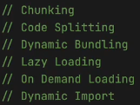And it does not make sense to put all our comp into one file.
* Ok, now what should I do?
* We should be doing chunking!, or code Splitting, or dynamic bundling, or Lazy Loading.
* **Is bundling good or bad? It is good, but its good to a limit, cannot bundle everything to ur app, u’ve o make logical bundles of your app**
* Just few lines of code can optimize ur production ready app to a next level.
* How do you think makemytrip would split this bundles.
* Generally in your large scale applications, u build different bundles based on the usecases.
* The senior enginner, the tech architect they do a system design. This will help u in ur system desing interviews
* **U’ve** to convience ur interview why u used bundling, and also, in makemytrip u book flights, but there are many other sections too, like hotels, home stays, trains and all but u cant bundle this all into one load it up, u bundle based on the usecases.
* When u go to interview u’ve to give smart answers.
* I only loads the component when user click on it.
* It also known as demand loading or dynamic import.
* Now let us see, how can we do this in our code
* Our app is not large enough to’ve bundles but lets see it.
* So, swiggy has something known as instamart also, do u feel instamart to be a diff bundle.
* Let us create a instmart component.
* Also add a path config to it
* **Let us try to do chunking**
* Where ever u r importing the instmart, u’ve to lazy load it
* Import lazy from react lib, it takes a function like 
* Save our app
* 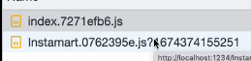Now open browser and in network u can see a separate instamart.js
* There is an error, which is coming from our error router.
* Why it is coming?
* When u click on instamart, it takes some time to load as it is diff bundle altogether, meanwhile react tries to render it something which is not there.
* **So in this** process react suspends the rendering
* Also if u go back to home and come u see the page, cause it is single page application.
* **Upon onDemand loading-> upon render-> it suspends the loading.**
* **Now** to handle this case, will be using something known as suspense from react lib.
* 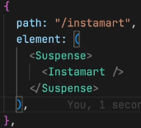**We can jst wrap it inside**
* **React will take care of it**
* **i.e., react** knows these components will be lazy loading.
* It waits to resolve it waits to resolve the **above promise, it is a promise.**
* Go read about it fulfill your curiosity
* In the intermediate time what should I be showing here?
* Shimmer
* So, Suspense tag contains a props, known as fallback, where we can pass whatever u need to show until and unless instmart is available.
* There is not need of chucking in small apps when u build a big app, u will be able to have it.
* Lets do this thing for about.
* In fallback u can’ve any piece of jsx.

**Homework:**

* **Create your own hooks**

**Recap:**

* We created our useRestraant hook.
* We created useOnline hook.
* We learned why we need hook, how we use it, when to create
* Also saw how we lazy load things why do we do lazy load.
* How do we chunking, bunlder spiltting.
* **NOTE: Never ever dynamically load your component inside another component.**
* **Never do this:** 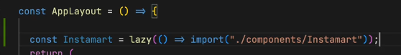
* **WHY?** Cause it will be lazy loaded after every cycle.

**This was the chapter 9, optimizing our app**

**12 Jo dikhta hai vo bikta hai 20/02/2024**

* Basically will be **learning TAILWIND CSS today!**
* Will learn how to write css
* Most popular css framework its tailwind css
* Lot of compines uses bootstrap, also most of them uses material UI.
* Why should we learn CSS?
* Should we using framework? But why?
* The primary reason to choose framework is to write optimized CSS, and it saves TIME.
* I want to cover over all perspective of how u can style ur react component.
* One way we’ve already seen, the basic native css file, index.css
* No matter what the component is we were styling in one large index.csss file it is the very basic way.
* Today we learn various ways of css
* 2nd way is scss and sass, if don’t know learn about it, it makes the css writing experience good.
* Now, what is the adj of using scss over nrml css? Nesting reusability etc.., at the end of the day this scss is compiled to converted to basic css
* How else? 3rd way? Inline. Inside the tags, it takes a js object {}, 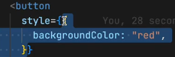
* Do you know why 2 braces?
* Well this is the faster way right?
* But is this the good way of writing css?
* Why-> reusability, hardcoded, repetition etc..,
* It is the heavy job for our browser, the processing is heavy
* Always try to avoid this, className is better than this.
* 4th way?
* Is to use library like, material UI
* When ever we are using webAPPs, we’ve common things in our page.
* We always have button, navbar, cards, list, menu etc.,
* Who maintains material –UI? Find it out
* It is a library, a fully loaded component library
* It means it have a lot of pri build component.
* This is the newer and faster way of building it.
* In uber we’ve to use base ai
* Should we use it or not? Is it a good way of doing it?
* What are pros and cons?
* Pros: easy to use, reusable, consistent UI, prebuild components, which is best, it depends on how u use it!
* Can I use 2 frameworks? YES
* At the end of the it is a package, so yah we can use multiple pckg, but we should not use multiple framework, not a good formate, it should’ve uniformity and consistency.
* Every website has vibe, and it make it unique.
* There is also a chakra UI, one more lib
* Go ahead see all of them and figure out what is good for u
* CONS: bundle size, it makes it heavy, and we losse lot of control how our design looks.
* Personal customization becomes hard!
* 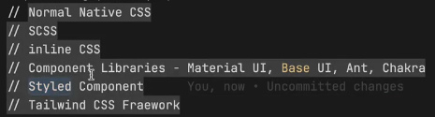It restricts u in some way
* Big pro, it makes development very fast.
* Now lets learn tailwing css framework
* When you go to an interview you should exactly know why all the above 3 or 4 ways cons amd pros
* It is very important thing in interview u should not skip it
* Now let us see what is tailwind css, what it is, how do we use it why do we use it
* Wait there is one more way it is styled components
* This also majorly used in react project
* EARLIER, we used to have separate files for html, js, css
* What we did with jsx is we are now writing html like code inside our js.
* 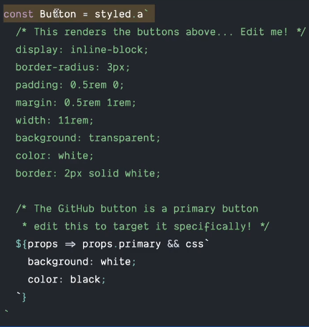Now let us bring css also inside our javascript files
* That is why styled comp came in
* This is a styled button component.
* It is like writing css inside your js
* What is the pain of it?
* Let us learn tailwind css with empty mind for now.
* Will decide this at the end, we like it or not.
* After 5 min break , in one go we see, and cover everything about tailwind css
* Bootstrap is also a way.
* It is a openSource css framework
* It has one of the best documentation go look it out.
* We can include this in many ways like cdn link
* 
* Tailwind css, works with just with the class names
* Every css style u put in wil be a new class name
* 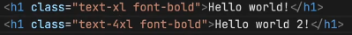this is how u add
* If u write 100xl it did no work, how at the end of the day we be knowing what to write!
* Basically I want to say is, everything in tailwind works with classNames
* How can I write this? Its in your documentation
* Tailwind search is great, it uses elastic search behind it
* For installing in parcel, go to framework guides and there is parcel
* If want to configure in react or angular there is different way!
* Basically u’ve to install tailwind css and postcss
* What is postCSS? So, basically postCSS is a tool for transforming css with javascript!
* At the end of the day it is used for compilation of this project.
* Browser does not understand this, we need to tell parcel that we r using tailwind and it need another compilation to convert those classes to be read by browser
* 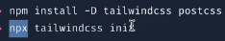Npx is to execute directly
* This npx command created a config file for us
* Tailwind.config.js
* Take homework, you’ve to find out what each of this is mean in that file

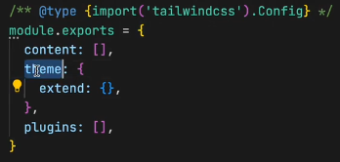

* in the conten we’ve to tell what files will be using tailwind
* All our component files right
* 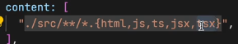Will be writing this way
* We need to configure our post css also,
* 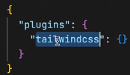By a postcssrc file, jst like we’ve babelrc
* .postcssrc file, inside it we configure this way
* So postcssrc file take this configuration, basically it tells our bundler tells our parcel In our project we would be seeing a lot of tailwind classes we need to configure it that when we bundling things up, compile that tailwind css into nrml css, that is the job of postcss
* 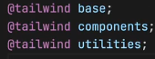Well, inside the index.css there will be nothing inside it only 3 lines.
* The configuration takes few steps, when u r doing it
* 1st install tailwind and postcss
* 2nd do a npx tailwind init;
* It creates tailwindconfig file, inside that file, u tell tailwind what files u want to scan.
* Now we need to configure our postCSSrc
* Then go to our index.css file and write this 3 lines.
* Now on words, I no longer be doing or using the index.css file.
* Not writing anything.
* Now our configuration is done
* Run it and see, all the our css is gone now
* Everything is broken now
* in todays assignment u’ve to delete all ur css also
* Now we try to design our app using tailwind css
* **1st of all lets try to modify our header itself**
* Let us make this header as flex box 1st
* How do u make it as flex
* we write **our className as flex,** our header things comes to adjacent to each other.
* Now I want to make space between them, how?
* **AKshay are u pad, u r saying to remember all this**
* **NO**
* **Here comes one extension that will rescue use**
* **It is known as tailwind css intellisense**
* It is very handy
* It will suggest us when we use it
* For **logo size I give h-8**, and for padding I give p-3
* Padding on only left side, pl-3 , for right pr-4, px for x axis(left and right),
* it is easy after 1 week of writing tailwind css, no need to refer documentaion
* try to make list as flex, in my ul
* then **padding to the li, i.e., top and bottom how, py-10**
* Gap between this, px-10, to all this li
* Now let me give a space between, how? Open tailwind doc what we will give, it is j**ustify-between.**
* Let us give the background color find it out?
* bg-pink-50, let us give shadow, also lets write margin my-3
* Now lets style the search box
* On the button, p-2,m-2, if no suggestions arrive use, ctrl+spacebar in vs code
* 
* Let’s modify our cards
* ­what if I want a my choice size, rather the preloaded once, for that I can use square brackets notations, w-[200px], it makes he width 200px
* In networks see the css, file we see it is small, the 1 we used are included.
* Who is doing this, parcel is doing this stuff, and taking help of postcss and tailwind library to ship it into our project.
* Tailwind got 1000s of classes, it make share that u will include only the one u used it, itmakes the css small
* Stick to the native tailwind classes don’t wirte dynamic cause tailwind understand it and it wont make new classes, less code.
* Try to use what it offers.
* Now, make the container as flex, it came in one row, wrap it up,
* It looks cool. 1 thing tailswind safes us from is timeee
* I don’t have to switch between html css and all
* I can style it on the go
* Also it is easy for debugging css
* When u hover on the button change the color, do it yourself
* Hover:bg-gray-500.
* Everything is there in the doc, go and look for it.
* As you are reusing it, u don’t ‘ve to think about optimization even if u use it many time, it is included ones in the css file.
* Also try to add on the search box, play with it.
* Lets see one more cool thing, so now lets say,
* How do u write media query in it
* Suppose I want to build a feature on my mobile phone.
* SO, my css should change according to width of my screen.
* People who don’t know about media query 1st of all learn about media query .
* Then work onthis
* Suppose if my website crosses the threshold of small device, we got 3 device s,m,l
* SO, as my small devices crosses, make my header purple.
* Change my background to 50
* Sm:bg-blue-50 md:bg-yellow-50
* This is how I write.
* Don’t do this on production app, this is for just learning.
* **And do this homework, on your small devices you want your logo to be full and the other to come down.**
* i.e., my logo to be full and centre line, this is your homework
* Let me discuss an imp point for your system design interview.
* Let us see the pros and cons of tailwind.
* **PROS:**
* Easy to debug
* Less code
* Easy to use
* No duplicate css
* Faster development
* Less bundle size
* Customizable
* **CONs:**
* High learning curve, new dev need some time
* it looks ugly
* consider seeing the components given in the site.
* The actual code is hard, it is not much readable
* Makes the className look ugly, well if not here it would be in our css file.
* Its your job to use it or not

**RECAP:**

* **Styling apps**
* **4 ways {explore all of these css}**
* **Today we did not study react**

**13 DATA IS THE NEW OIL 21-02-2024**

* Handling data for a webapp is the most critical thing u’ve to do
* There are various ways u handle data.
* The buttons, color, div, view is the UI layer
* There is one more layer it is the data layer
* This combine builts our fronted single page application
* To build the UI layer, we write jsx, at the end we convert it babel converted into javascript objects, the big object structure is Virtual DOM.
* **The whole UI layer is powerd by data layer**
* What is that data ?
* **How data within the application is maintained**
* **It is the states and the props**
* **Data is handled in states and props**
* But do we only manage data layer with state and props, there are more thing to it
* Tell difference between state and props?
* **Basic diff is, if you got a container and you want the scope jst to that container, only within the componenet it is known as state it’s local variable.**
* **Props are the value passed from one comp to other**
* Now lets say I created a state variable inside app.js
* 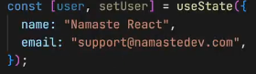
* And I want this to pass this thing to restarantCard
* Well how do I pass it, all says props props
* Well my applayout doesn’t have restrauantCard right,
* So where is my restaurantCard it is in my body.
* Therefore, 1st I will pass to body from applayout.
* 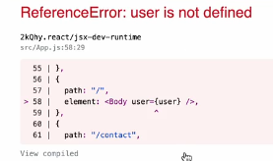****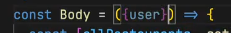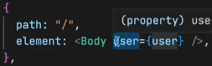 **ok now** we are getting error user is not defined,
* **Cause**it is basically inside approuter the config thing, we are not passing it right, cause it is out of the scope of the function of config to have the state which is in appLayout
* 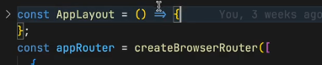**the state is in applayout**
* 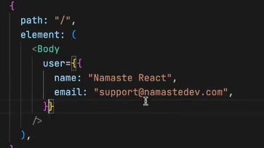Now suppose if I pass the object directly.
* Now it will work.
* 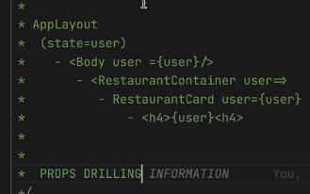How it coming it is like a chain it is coming from applayout to body then to your restTaruantCard
* **This all process is known as props drilling.**
* **Please download react dev tool is best extension** available this tools come into picture when u build big application, I want you to build big application.
* Open insepect, open deverloper console, u got new things compoenent and profiler, click compoenet. It shows u the representation of dom, in hierarchy it helps u debug your app a lot.
* **This tools helps us to debug the data layer**
* **When u click on the card, u can see what props are being passed.**
* **This hierarchy is helpful for prop drilling.**
* What if I want to pass **the data from child to parant**
* **There are various ways to do it, let me tell u there are very less cases where u need data from children to parent**
* How can we use it?
* **We can build our custom hooks!**
* Jst **like useParams can be used anywhere**.
* I will tell u various ways, telling u cause it is very …
* Is props drilling is a good way, as saw, we updated 3 files and our body isn’t needed it. It makes our code clurtered, if u got herirarcy of 2 or 3 level its ok
* **But if u got 10 levels,then it is not a good way.**
* So **we use redex for this**, but today we are not studying reduc, today we learn more ways of handleing data.
* One more disadvg of prop drilling is, **suppose u change one thing in a component the it will rerender lots of component it is been coming from.**
* It is unnecessary code which we don’t want.
* As the user is not been used in the body component.
* Lets learn one more concept for that I had to build one scenario.
* Lets go to the instamart page and build something inside it
* I want to show information about instamart
* 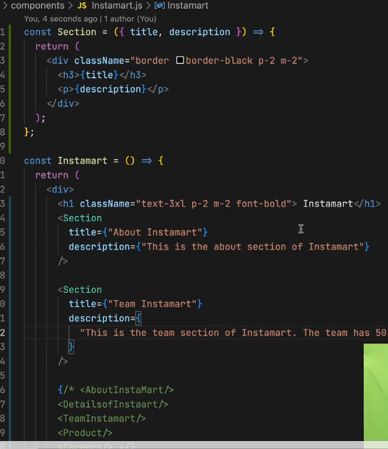this is how we are doing this.
* 
* **Let also have a hide and undhide thing for description**
* 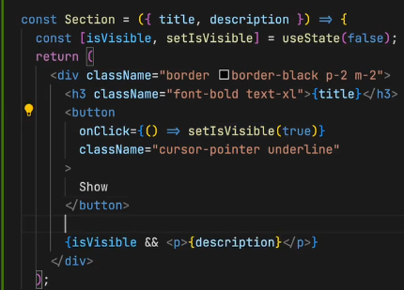**this way we do it.**
* **Also lets create hide button**
* **And will** add those buttons in ternary i.e., if it shows then only
* **We’ve built an accordion component, it took** 5mins cause we exactly know what we need to do.
* **Like, material –ui-accordian.**
* **Now heres the challenge, I want to built a feature, where if I click on show over here, it should collapse other opend accoridans.**
* We want to build collapse able acordian, How do we built it
* There is a important concept on how we do it, u’ve to understand this and keep in your mind. It hleps in lot of things.
* **In react debug tool, see the section component**.
* **We will be able to see that all of the section maintains it own state, we can see the value of it**
* So, when I try to show some, then I want to modify the state of its siblings
* How will we write this in our code.
* The thing is we cannot dooo that, modifying another subling
* We’ve to do this.
* **We’ve** to play smart game instead of maintiaing their own state
* **What we can do is, we can maintain the state in its’ parent** cause now parent has its control over all his children
* **This concept is known as lifting the state up**
* **My parent instamart gonna control this all**
* **Which need to show and which not.**
* Now I want parent to maintain the state of the children
* For **that I’ve to create this way  
  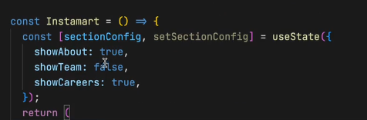**
* **And at each section pass this**.
* Suppose now I want to only show one and hide all others.
* 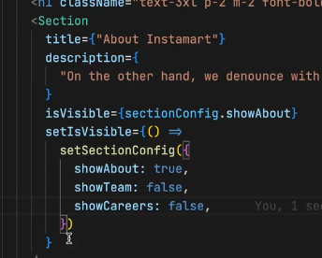I will be using setSectionConfig, on onclick of the button which inside my component.
* Now the this way I’will pass, for all the section 1 wil l be displayed and other be false.
* **If I want to create more sections, I do the same I will add one more obj in the state,**
* 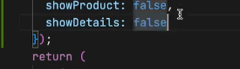**this way, and for each and every thing I need to make this true and false.**
* **This is type of code is known as SHITTTTT**
* **This code is not maintaible, readable, garbageee**
* **How do we optimize it.**
* **Realize that data is the new oil.**
* **Your data should be very well maintained in your app.**
* The code is not written well.
* Understand the things, the conditi**on is you just’ve to show one thing at a time.**
* **I just need to track what I need to show.**
* **There are multiple ways to do this.**
* What u can do is, u can pass keys here also, the key can be name of the section and u don’t need to have a big config for ur state, rather u can’ve info about which sec is visible.
* Do I need an object now NOO
* U can keep indexs for ur section or u can keep key for ur section.
* At a time only 1 section is visible.
* See there are multiple ways to do this, I’m telling u jst one way.
* 
* **And in** isvisible prop I will pass, 
* **For the about section,** and ===’team’ for team section etc.,
* **We are just controlling all this sections** with just one state variable.
* **Now** we also want the button to work
* **Will set our visisble section from here.**
* 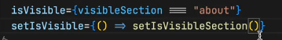What should I write here
* If I write a key name here will this work,
* **this way**
* **It will work when u click on the show, but wait when I click on the hide, it is not hiding.**
* **It is not updating the state properly,**
* **Now this is the homework…**
* Think of this section as blackbox, these are controlled by its parent. The parent will **say isVisible is true**, then it will be visible if it is false, then it will not be visible.
* **isVisible controls, whether it is visible or not, setIsvisble controls what is visible**
* work on ur homework
* **HINT:** u have to modify the logic of this function 
* **Show works but the hide not for nw**, think about the signature of this component, **i.e.,** what it is doing on click 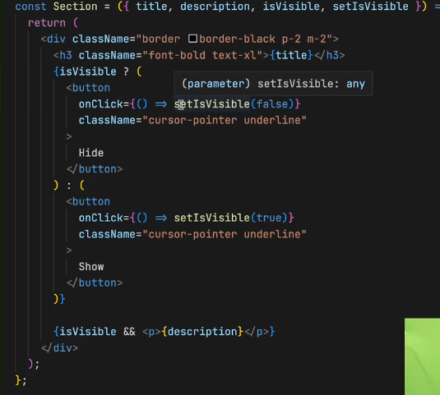u ‘ve to modify this logic, **think about it this is a homework for u**.
* **Today we studied, props drilling, lifting the state up and data is the new oil, it s most important part for manaing ui layer.**
* I will show u one more cool thing about the react **dev tools its profiler**. When u **built large scale application with so many components with it it becomes tuffer to built.**
* It will be recording, it shows how the page was rendered
* If I just strt rec and move any where to my app, then it shows what happened shows u flame graph shows what happened and time the component took to load.
* With this things u make ur app performance.
* Can also rank our compoentn which is taking time, and we can optimize accordingly
* **Lets now move on to another topic.**
* Suppose I want to build a feature.
* **Lets say in applayot I got this user info**
* 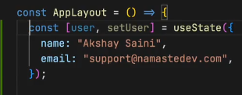
* **And I want this user info in my card**
* **How can I get, props drilling**
* **Suppose I want this inside header, or all across my app, anywhere.**
* I can keep drilling my props anywhere.
* **But it is bad approach.**
* So when **u need data everywhere, u need to store it in a central space. Some saying Can be local storage, but it is not reliable and updating local is pain heavy operation**
* **React gives acess to the central space known as context.**
* **React context**
* **Some big companies uses redux-store**
* **Mobex, ngrx some lib can do this flex,**
* Now react got its **own react-Context**.
* Some saying can we create global variable.
* Assuming context to be a big object or some piece of data
* Let us create **a context in utils create a file, UserContext.js**
* **U’ve to import creatContext from react, it is basically a function**
* 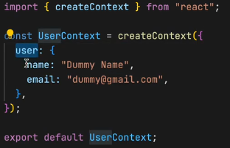It takes in the data that need all across ur application, basically default val of ur contex.
* How would I use it?
* Suppose in header In login button side, I want to show this name.
* How will I show this.
* I will import, useContext from react.
* **At the end, the useContext a hook**
* How u use it?
* **Inside the header file **
* **Now the question comes can I’ve more than one context or not**
* **YESS**
* Add this to the loggin place.
* In **the browser u can see the name.**
* **I** **don’t ‘ve to pass any props.**
* State and props are tied to component, context is separate, it is not specific to any comp
* 
* U can put span also
* Rather h1
* **Can I use this dummy name inside our RestaruantCard**.
* Let us use it
* In**side restaurantCard, import useContext, and pass userContext**
* **And the name get in all cards**
* **Let us try in footer also**
* **Now the question comes, why do we even need props then**
* **Can I keep everything inside context? NOOO**
* **U don’t use context for everyting, u use when data is req in all over the component.**
* **Now about.js is a class component I want to use here? How**
* **Here we use it as a component.**
* **U do something like <useContext.Consume></>**
* 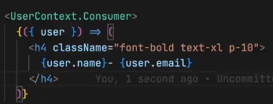

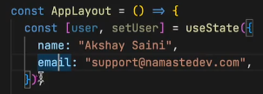

* 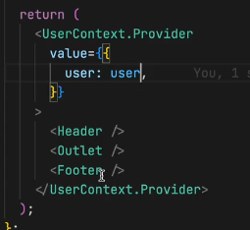Now suppose we don’t want dummy **value, I want my data to be real data, which comes over here. Make a API call**
* **SO, You can modify your userContext using a provider.**
* **U got userContext.provider**
* U can **override the default value**, like
* **I’ve jst imported my userContext and wrote**
* **So, whenever my user state variable is modified then it is modified in everywhere as well**
* **This is the beauty of context**
* **Why did I wrap everything my provider**
* Cause I’m using this data everywhere, I did not provide in footer, or header is outside the provider.
* Can u guess what happens,
* U see it it will display dummyName.
* **U see it, I can modify my contex for the smaller portion of our app, u see it , it is very powerfull**
* I **can use the same context, but I can pas diff data to diff apps**
* **Logically I should not do this right**
* Now let us try to modify this context
* 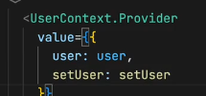**Let us have an input for modifying it**
* **Next to search button let us create another input box**
* From applayout I will **also pass this setUser**
* **We will get this using** by destructuing
* 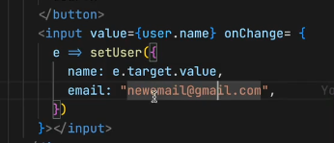u **can see this on the go, when I modify it it is modifying everywhere**.
* **Think about the reconsilation process.**
* **Very fast**
* Lets **create another text box for email**
* 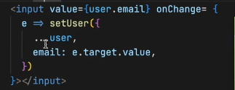**if u don’t understand … go and learn javascript**
* Now think about what happens to my profiler.
* 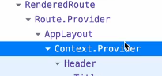**saying** context.provider but how will I figure out this.
* **U can do one more cool thing.**
* **U can give a display name inside ur userCOntext.js file**
* Now, if u update here and after u load ur abut page u can see the update username and email, u see this is how powerful it is
* If u built this in js it takes days
* This is it about today, DATA IS THE OIL, as the world doesn’t work without oil

**Practice:  
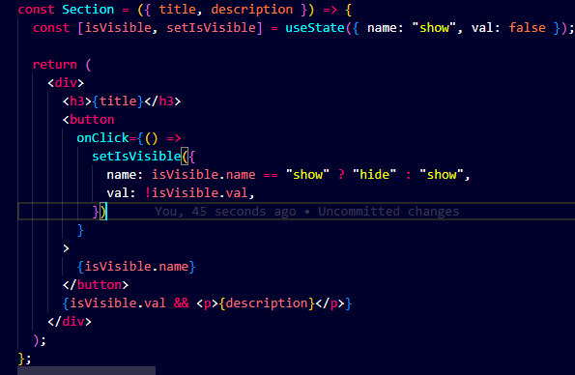**

**15 Lets Build Our Store 24/02/2024**

* Todays session is all abou building our own store.
* Learning important concepts about, how we can manage our data very effiently into our web applicaton
* We discussed lst time 2 types of layer UI and data layer
* Both layer works in sync
* All this is happening over our browser.
* Today we are goining to see, more better ways, more complex ways of handling data into our application.
* When u’ve to manage big full fledged app, production ready big large scale application.
* **For that we use a library REDUX.**
* Why do we need redux, we need it to manage our data layer of our applicaton,
* We used context to avoid props drilling.
* GO get your note book and pen
* When your application grows a lot then libraraies like redux comes into picture.
* We can use context for lot of things right.
* Last class we made the context for userData
* Also THEME, can use context to switch from light to dark theme.
* And all the other components are reading from that context.
* But to manage or data properly we can use something known as redux.
* Instead of creating different context we can’ve a redex store.
* Let me tell u a little history of react.
* Why do we use redex?
* So, redex is used for data management.
* There were major issues with using redux.
* When use context and when use redux.
* So when u r building small application using context is ok, when ur application grows then lot of context becomes tideous, redux gives u a proper way of handling, managing, modifying the data.
* Some companies use alternatives of redx.
* There are cons of redux as well.
* What is the major big problem with redex.
* It is complex to setup, very complex setup, it has a huge learning curve.
* And it was very tough to learn redex.
* Redux and react are completely different
* There is lot of complexity, with redux so now, redux has come up with redux toolkit.
* We are going to study redux Toolkit
* 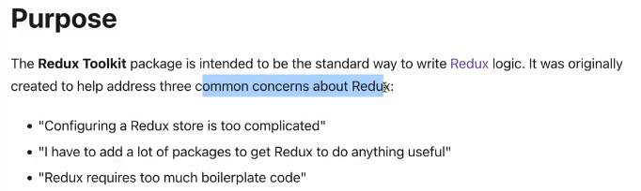
* Before that let us discuss the architecture of that.
* So today we are goining to build the cart flow, the whole cart.
* U will add item to the cart, it involves lot of data wirte.
* A disclamer, What we are going to discuss is very important thing I should say.
* Should pay 100% attention.
* 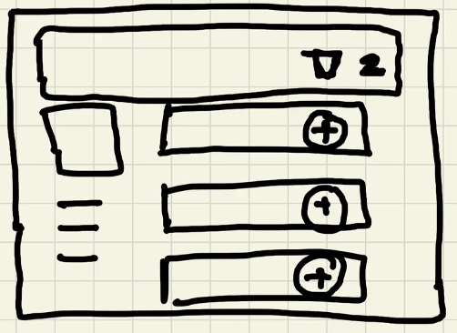
* At the end of the day redux store is a big all object.
* Which has different section.
* Important thing is just like our context, what components will be able to acess my redux store, all the components will be able to acess my redux store.
* So it is basically like a diffenet store all together. This is kind of a separate thing. Store is a central thing it is not tied to any component.
* Context is a separate entity, same as redux is also
* Irrespective of where our component lies we can acess it anywhere in the app.
* Can we’ve multiple context? Yes
* But in redex we will have a single thing, it store everything is put into a store. A whole large big store with a lot of data
* U may say it’s a poor thing to keep lot of data inside it right?
* No its not a poor thing, we will create logical separation into our store.
* We will create slices for our store.
* What all slice can our app have, it can have a user slice, a authentication slice, cart slice, theme slice etc.,
* A slice is a portion of your store.
* Our **components cannot directly modify our store.**
* How it works is, when u click on the + button it will dispatch an action, this action will call this function and this function will modify our cart, 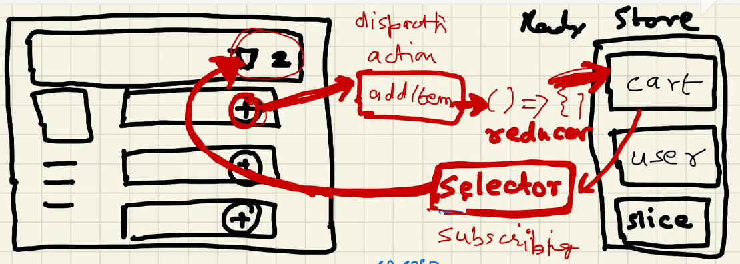
* Cause we cannot directly modify our cart.
* Why why why can directly.
* When there is a large application, SO you don’t want random components to randomly modify.
* U will get the answer by the end of the session, this is the best way of modifying data.
* Why do we’ve a microservice architecture, why can we put all in one place.
* **It is separation of concerns** and it is also modular. Every component has its own responsibiltiy.
* This what I’m explaining it is an architecture of redux.
* The function we are talking about is known as **reducer.**
* This is an holistical view of what goes behind
* Now how will I read from the store.
* For that, there something known as selector
* Selector means I’m selecting the slice out of that store.
* Selecting the portion of that store.
* At the end of the day, selector is a hook, and hook is a function.
* 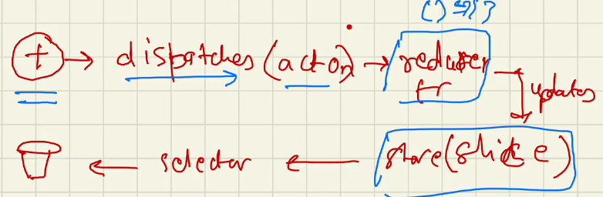
* When u use selector it is known as subscribing to the store.
* It is like in sync with the store.
* Let us take a break and will code this all up.
* Now u should be able to tell, when someone asks what is been happening inside redex store.
* Subscribe in one line is,
* **The cart component is subscribed to my store using selector.**
* Whenever the data in my store changes my cart component will automatically changes.
* Let us see this in code:
* Today we need one more extra lib, it is redux toolkit
* 
* And also  why 2 libraries no one questions this.
* Redux core job is to maintain the store, create the slices and maintains it. The 1st lib we installe that is core of the redex.
* The other libreary is the bridge between redux and react.
* Jst like react and react-dom
* Let us create our store, I’m creating this in my utils, store.js
* Import configureStore from core lib
* 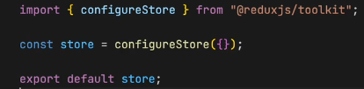this is our store.
* Jst like we’ve provided the userContext ot whol app, I wil provide this store to my whole app.
* How ?
* With provider component, this component comes from react-redex will give me this provider.
* I will wrap my whole application to my provider. 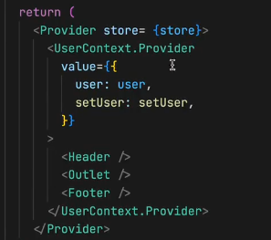
* My store is coming from my utils/store.
* We are passing props in the providerTag.
* What was the function that we used to create our store, it is configure store it come from **rtk(redux toolikit).**
* Now we need to provide this store to my application, we use the component known as Provider, it is coming from react redux.
* Now we are ready to do actions. Our store is empty right now, let us fill this with something.
* So our store should contains slices.
* Giving a store prop is important in provider.
* U can create slice in store.js file itself, but will create all my slices in new file.
* Named cartSlice.js
* I will use createSlice to creat slice, and will import from rtx.
* I will’ve a name and a initial state for my cart.
* 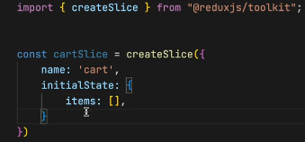 Now I’ve created my cart slice.
* Name Is cart and initial status is an empty array.
* How do I modify our cart.
* By creating a reducer function.
* The reducers contains mapping of actions to a reducer function.
* 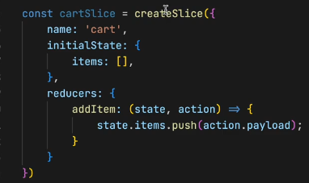the reducer function takes 2 things, 1st is state, the other thing is the action payload.
* Actions(this is the place where I get in the items which I will had to add into my cart) and the state is the intial state.
* Now let us write some logic to modify our state.
* 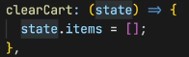the state over here is always the previous state, when we see working we will understand the
* Let us create clearCart
* A**lso try to understand that this will not return anything.**
* It takes a state and directly mofifyies it.
* Let us give banana and apples to items
* Let us create a reducer function for removeITems as well
* We’ve created our slice write, we will now export something from it. My components need to access this slice write so I will export actions and reducer from this slice.
* 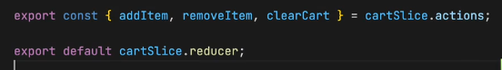this is the syntax, watch it properly.
* Reducers are exported by default and actions as named exports
* It combines all the reducers function and export carSLic.reuducer. not reudecers.
* 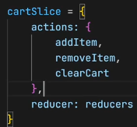For actions that is how we export the actions. Named export
* This whole my look like this
* Now I’ve created the slice but my store does not know about it right, I’ve to put my slice in my store as well.
* 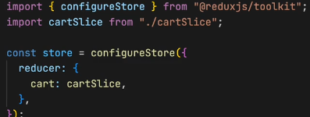This how we do it.
* Let us revise what we’ve learned till now.

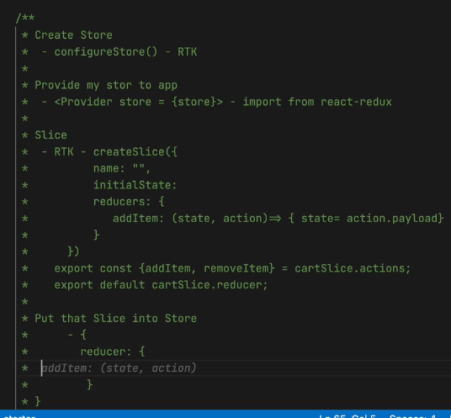

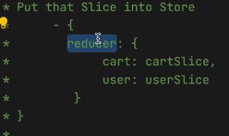

* Now it is time to play with things
* Now let us subscribe with the store.
* We do it using useSelector.
* Lets show the items in our cart.
* Where this useSelector hook comes from?
* It is bridge between redex store and component it cmes from reactdredux.
* How do I use it?
* Like I want to subscribe to my store cart items.
* 
* **I will** show this way in the header 
* As I got banana and apple by default it will be displaying 2,
* 
* **We’ve our store built in and we’ve subscribed to it.**
* All the code we’ve written does this to use.
* This is nothing we will modify our store.
* In our restrarantMenu/Details Component add button named add items.
* Lets dispatch a action also.
* 
* Will implement handleAddItem function, now comes the important part how do I dispatch a action, how do I add my item to the store.
* What I’ve to do in this handle function.
* i.e., dipatch the action and pass the payload. 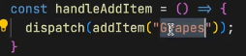
* Where this add item comes from ?
* This will come from slice. Remember u exported it
* 
* **this way we import.**
* Where will the dispatch comes from another important hook, useDispatch it is imported from react-redux.
* This all is related to what we discussed the architecture of the redux
* 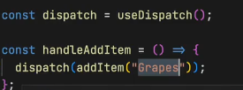**let us see it will work or not in browser when u click it should inc the cart count.**
* Let us dive deeper. After 2 min break.
* Let us try to add button to the menu.
* When I click that button it should reflect the cart
* Provide tailwind css
* In that button in onClick will pass a function named addFoodItems(item) also pass item in that func
* What should I do on onClick of the button ?
* Exactly I should dispatch and action.
* 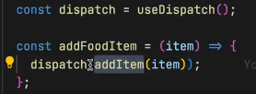**Now do u think this will work?**
* Let us also log our cart, let us know what Is going inside our cart.
* Initially let us keep our cart empty
* So we can see that it is happening the whole redux architecture lifecyle is hapeening
* The dispatch action provider selection etc.,
* Everything is automatically working
* Let us build the card page also.
* Will create a cart component and also will’ve route to it.
* I’m not doing anything new, this is how quickly u built ur cart page.
* It didn’t take much time, was there any word that u did not understand.
* This is how we develop fast react application.
* Will you be able to add quickly shimmer on to this and lazy loading. Into the cart
* Lets get the items from your store how do I the cart items from the store now?
* U people will tell me. useSelector hooks.
* Our useSelector hook takes in a function, it is subscribing to the store. What should I write, take your notes, this is the very important thing what I’m going to tell you now.
* Very important thing about redux, I’ve asked many a times in the interview.
* This is the most important part while using redux, your useSelector, what is useSelector used for to subscribe to the store, this is the place where u tell what this component is subscribing to.
*  if I write store over here, it is subscribing to whole store. If I’m writing store.cart it is subscribing to cart slice. If store.cart.items then it is subscribing to only that array of items.
* this is where most members make performance mistake.
* What people do is they subscribe to the whole store.
* **this and then **this way.
* **Or I can  do this.** This is the major performance improvement u can do why?
* If my cart is subscribing to my store, what will happen automatically every time my store changes my cart will change. It will rerender my component.
* Now, if I’m subscribing to my store, every time my store changes it will rerender the component.
* In large scale production app the store is hugeee
* It gots so many slices so much data.
* Do u want this cart component to renrender everytime when anything changes in our app.
* Its ill logical.
* **SO WHAT YOU’VE TO DO IS U SHOULD SUBSCIBE TO SPECIFC PORTION IN THE APP.**
* It makes a major performance improvement.
* Always subscribe to specific portion of the app.
* Even in the interviews tell them u are subscribing to this. Its very important.
* Let show the cart items now.
* Lets also import restaurantCard and send the items to it.
* But it wont work right, cause it is restaurant card menu item card
* It should like foodItem card like that.
* Lets create a foodITem.js
* In the food item, we got name, cloudinaryImage, category. Add such few items price and all.
* 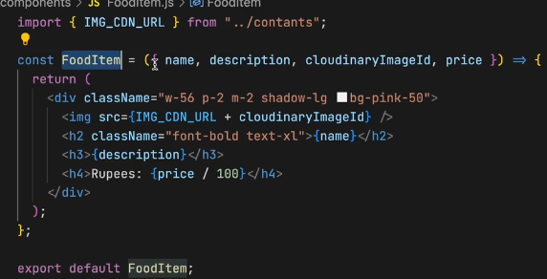
* we cant pass this way in cart.js cause we are accepting the destructruded obj
* So this way I pass 
* Now I will map over all cart items.
* SO, if you code strategically in future u’ve to code less.
* I also need to’ve key remember it.
* Try running the app, all of this is working amazingly.
* U see tailwind has made this easy. We are able to add css quickly. Otherwise i would think about className and all.
* Here’s the cart.js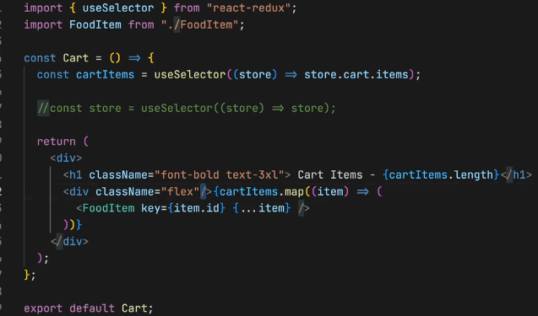
* **Now let us built a clear cart as well it will revise everything for us.**
* **Next to the cart items.**
* 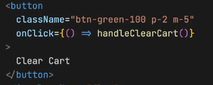implement the handleClearCart function.
* 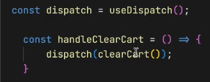**will import clear cart.**
* 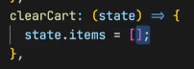Should I pass payload here, no cause it did not need any payload. The img is from cartSlice.js
* **Add something into the card, add click the clearCart button**
* When I click on clear cart or cart is empty.
* Was it hard to dispatch. It was soo easy, it is very easy to read stuff ones u configure it
* This is the summary of the whole day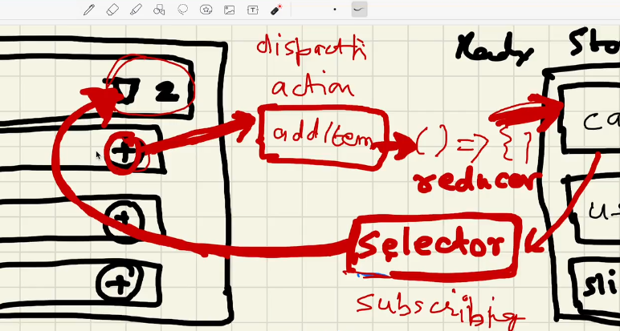
* Most react developers don’t understand how this all things are working.
* Now what you’ve to do 1st of all is, read reduxtoolkit docs everything makes sense to you.
* Lot of people asking thunk? No I’m not going to cover thunk, middlware those are complex topics in redux this was suppose to be a Namaste React. It wil take a lot of time.eact. It wil take a lot of time.
* But u read about those.
* Let me tell you the last thing of the session.
* There is something known as redux dev tools.
* This dev tools is a super powerful tool if you are working with redux, blidny install it.
* It will make your job very easy.
* U can see what is been happening.
* In the app if the app is using redux.
* The extension track each and every event.
* I can debug if something goes wrong.
* It even wrote testcases
* This extension is very powerful.